Chapter 1
THE PROBLEM AND ITS SETTING
This part presents an overview of the research problem, covering the introduction, theoretical and conceptual frameworks, problem statement, proposed hypotheses, study limitations, boundaries, research significance, and definition of key terms. Together, these components establish the foundation and direct the study's emphasis.

Introduction
The communication for drones in areas affected by disasters is very important. It depends on how radio signals travel and if the connection's stable. The physical characteristics of radio signal propagation and connection stability heavily influence the reliability of communication for Unmanned Aerial Vehicles (UAVs) in -crisis scenarios. When drones fly low things on the ground can block the signal. Research shows that at heights, like 10 to 50 meters obstacles in the environment play a crucial role in network breakdowns which can cause delays. In some cases, there can be delays of up to 830 milliseconds when drones fly close to the ground (Bordin et al., 2024), so, to avoid this we need a signal (Khor et al., 2025; Muladi et al., 2022). The Two-Ray Ground-Reflection theory underlines the potential for delays and a signal strength of at least 10 decibels is needed to prevent disruptions. For operations we need a communication setup with two links. This setup should have a video delay of than 105 milliseconds (Mahdi et al., 2025) at 5 gigahertz and a packet loss ratio of no more than 3 percent at 915 megahertz (Arslanbenzer et al., 2023; Bordin et al., 2024). To meet these standards, we need to follow rules for signal strength. The Received Signal Strength Indication (RSSI) levels should be -85 decibels or higher for video data and -80 decibels or higher, for telemetry. This ensures that the network works well within a 200-meter range. Unmanned Aerial Vehicles (UAVs) can then be used effectively in -crisis scenarios (Zhu et al., 2021; Zhao et al., 2024).
These rules are important for search and rescue operations after a disaster. This is because search and rescue operations face problems when people can die quickly. Doctors and emergency workers follow the Golden Hour rule. The Golden Hour rule says that if people get help within the first sixty minutes of an accident, they are more likely to survive (Maurya et al., 2022).
Search and rescue operations are very difficult when there are disasters. These disasters can destroy things, like phone lines and power grids (Alsamhi et al., 2022). When these things are destroyed it is very hard for rescue workers to communicate and do their jobs. This makes it very hard to find and save people who're trapped. Search and rescue operations need technology to work properly in these situations. The search and rescue operations need this technology because it is very hard to find people without it (Alsamhi et al., 2022; Sharma et al., 2022).
While UAVs are increasingly utilized to expedite SAR missions, current drone technologies exhibit substantial limitations in these harsh scenarios (Lyu et al., 2023). A primary technical bottleneck is that standard commercial drones often rely heavily on cloud-based artificial intelligence processing to analyze surveillance data; this architectural dependency leads to total system failure when internet connectivity is severed—a common occurrence where public communication infrastructure is destroyed (Alsamhi et al., 2022; Tai & Yu, 2022). In such environments, it may take days or weeks to re-establish a functioning communication backbone, rendering cloud-reliant AI modules effectively useless during the critical "Golden Time" (Alsamhi et al., 2022). Furthermore, platforms utilizing standard Wi-Fi or cellular signals suffer from limited operational ranges and high susceptibility to signal interference (Sharma et al., 2022). Conventional UAVs necessitate constant manual control by human pilots via continuous visual feeds, yet research indicates that human operators cannot effectively navigate highly obstructed or hazardous environments without a reliable communication link, leading to high susceptibility to human error (Lyu et al., 2023; Sharma et al., 2022).
To fix the problems with technology this research suggests using AERIS. AERIS is a system that uses drones to send data and help find people who're still alive after something bad happens. AERIS is a drone that can work on its own without needing the internet or big computer systems. It has components that can look at the information right away. This means AERIS can look around and make decisions without being connected to the internet. The AERIS drone also has cameras that can be seen in different ways like in the dark. It puts together the pictures from these cameras to help find people even if there are things in the way. AERIS uses a set of instructions that anyone can use so it can fly around by itself. AERIS can look at the area and find people who need help without someone needing to control it. The AERIS system is good at searching for people and rescuing them after something bad happens. AERIS is a help with search and rescue, after a disaster and that is what AERIS does.
The primary objective of the AERIS system is to facilitate rapid, decentralized situational awareness and the dissemination of verified GPS coordinates of survivors via a robust, localized telemetry backbone. This is achieved through a dual-link hybrid communication framework that decouples critical navigation data from high-bandwidth surveillance streams to maintain an optimized Age of Information (AoI) for rescue personnel. By putting Edge-AI processing right on the Raspberry Pi 5 we can make our system faster. This helps because it reduces the time it takes for things to happen. Normally when we use the cloud it takes around 150 to 200 milliseconds for things to happen. With Raspberry Pi 5 and Edge-AI we can make this time much shorter. We are trying to get this time down to around 105 milliseconds (Mahdi et al., 2025; Ntousis et al., 2025). The researchers are specifically focusing on the transmission architecture to optimize these RF parameters; the study aims to use these data findings to not only meet these theoretical and empirical benchmarks but to actively exceed them in the proposed solution, establishing a new standard for decentralized, infrastructure-independent disaster response.

Theoretical Framework
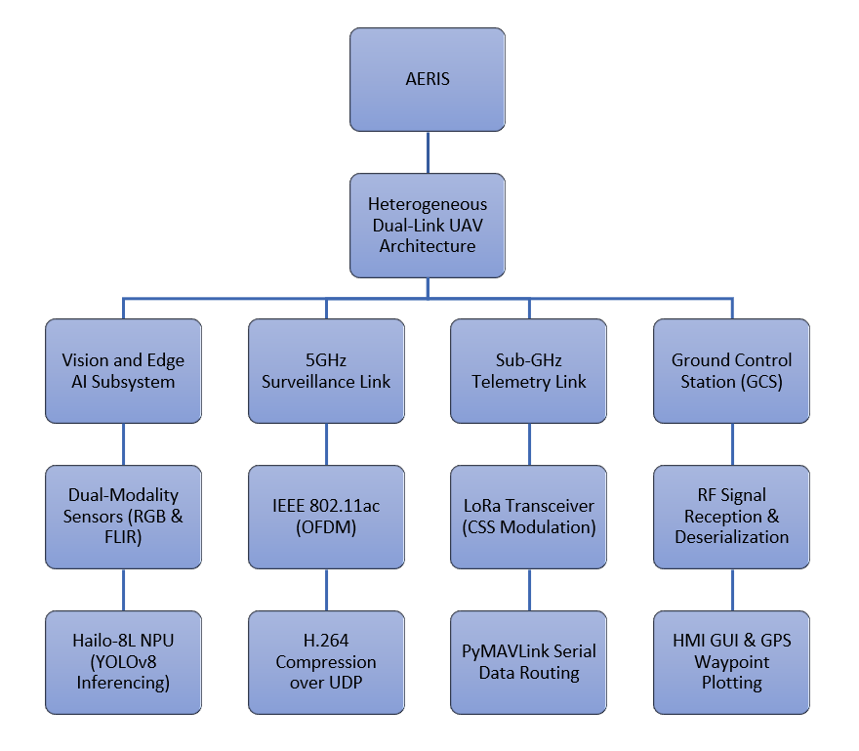
Figure 1.1 AERIS Theoretical Framework
In a recent study called Performance Evaluation of UAV-Enabled LoRa Networks for Disaster Management Applications, Saraereh et al. (2020) evaluated the performance of unmanned aerial vehicle (UAV)-enabled Long Range (LoRa) networks specifically tailored for disaster management applications. The researchers investigated the link budget configurations and quality of service constraints of deploying an aerial base station as a relay node when terrestrial network infrastructure collapses. The technical breakdown of this methodology focused on evaluating packet delivery ratios, average buffered packets, and end-to-end latency across variable flight altitudes and communication distances within a simulated disaster zone. The results showed that putting the gateway in the right spot, based on how well the signal is working, is lot better than just looking at how far away it is. This really helps improve the quality of the signal and how up to date the data. This study shows just how important it is to have nodes that do not rely on existing infrastructure. The aerial gateway helps keep the network working and stops delays in communication. Make sure the data streams are dependable when people are responding to emergencies. The aerial gateway is important for keeping the network connected. The data streams are dependable during emergency response operations. The aerial gateway plays a role in this.
Similarly, in Malaysia, Abro et al. (2025) developed a modular framework for advanced unmanned aerial vehicle control by integrating a Pixhawk flight controller with a Raspberry Pi companion computer. The core objective of their study was to establish a deterministic real-time routing environment that offloads computationally heavy processes away from the primary flight control system. Technically, this architecture establishes a low-level physical layer interface over a Universal Asynchronous Receiver-Transmitter protocol that bridges the flight controller's telemetry port directly to the companion computer's general-purpose input-output pins. This serial data pipeline works with fast speeds up to 921,600 so it can send vehicle information and important commands quickly. This is important because it helps the vehicle keep working and does not cause any problems during flight. The serial data pipeline is particularly useful because it makes sure the vehicle can keep working even if something goes wrong. It gives us a good base for the computer to make decisions quickly and do tasks like looking at things and planning a path without needing help from outside systems. The serial data pipeline is good, for this because it allows the vehicle to do things on its own like path planning and computer vision tasks without needing any help.
The technical breakdown is about getting good video frames at the edge. We are talking about the video stream which is big at 200 Mbps. This big stream then gets made smaller to, around 5 to 6 Mbps. The video frames are what matter here. We need to capture high-quality video frames at the edge. This is done using hardware that helps with H.264 encoding. The compressed video is then sent over User Datagram Protocol channels. This process focuses on getting the frames, it does not focus on fixing all the data errors. If a frame is corrupted, it has been dropped which happens at the side using jitter buffers. It does not wait for the data to be resent. The importance of this system is its delay. It has a round-trip delay of 105 milliseconds; this short delay helps in reducing lag. It also helps in making decisions in any emergency situations, such as rescue operations. The video stream and User Datagram Protocol are key here. They help achieve this delay. The video quality and speed are crucial. They make the system effective, for high-speed rescue scenarios. The technical breakdown and User Datagram Protocol work together which provide a reliable video stream.
The software stack uses a file system and request-confirmation algorithms to manage telemetry logging into local databases. These databases sync to cloud servers when the vehicle reconnects to the network. This approach is a step forward in emergency coordination. It shows that resilient multi-hop packet routing can work at flight speeds of ten meters per second over 8 kilometers. This completely removes points of failure. The vehicles software stack relies on this approach to handle telemetry logging into databases. It uses request-confirmation algorithms and asynchronous file management to ensure that data is totally secured over the network. When the vehicle regains network connectivity, the localized databases sync with servers. The approach proves that multi-hop packet routing can be securely sustained over the network at high speeds, which the software stack manages telemetry logging into databases. These databases then synchronize to cloud servers once the vehicle has a network connection. The approach helps prevent points of failure by using resilient multi-hop packet routing. This routing works at flight speeds of ten meters per second. It works over a range of 8 kilometers.
In Malaysia, Aizat et al. (2023) developed an automatic directional antenna tracker system to enhance the operational range and signal stability between a moving UAV and its ground control station. The primary investigation centered on mitigating the high susceptibility to signal attenuation and cross-polarization fading that conventional omnidirectional receiver antennas experience during aggressive aerial maneuvers. Mechanically, the system incorporates a high-gain Yagi-Uda directional antenna array mounted on a motorized biaxial pan-tilt gear reduction mechanism steered by real-time Global Positioning System coordinates transmitted from the aircraft. The tracking algorithm programmatically applies the Haversine formula to compute continuous yaw and pitch angular variations, driving adapted direct-current servo motors to maintain a precise boresight alignment within fractions of a degree up to a radial distance of 180 meters. The practical significance of this design is its capacity to eliminate manual tracking errors and maximize signal energy focus, which directly secures uninterrupted high-resolution telemetry and data reception in highly obstructed post-disaster environments.

Conceptual Framework
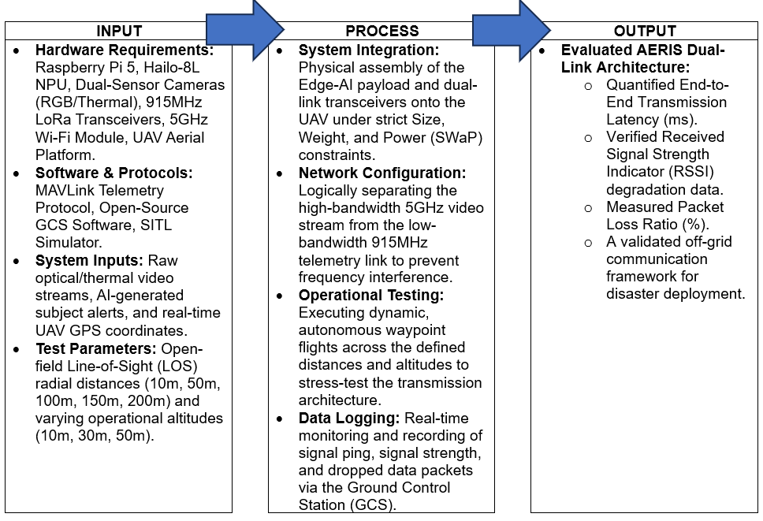
Figure 1.2 AERIS Conceptual Framework
Figure 1.2 shows a diagram of this study's conceptual structure. AERIS employs an Input-Process-Output (IPO) model to systematically evaluate the resilience and efficiency of an off-grid, dual-link communication architecture for autonomous Unmanned Aerial Vehicles (UAVs).
The system uses a file management system. Request confirmation algorithms to manage logging into local databases. These databases sync to cloud servers when the vehicle reconnects to the network. This approach is an improvement in emergency coordination. It shows that resilient packet routes can work at flight speeds of ten meters per second over 8 kilometers. This completely removes points of failure. The system is really dependable. The system includes a high-performance edge computing payload with a Raspberry Pi 5 and a Hailo-8L Neural Processing Unit. It has sensor imaging, including thermal images. It uses transceivers that work on 915/923MHz LoRa and 5GHz Wi-Fi. These components were controlled by MAVLink telemetry and special software like Ground Control Station software and simulators. The system manages lots of data streams. These include video feeds from cameras. They have alerts when the system detects something, like a person or an object. They include information about time and location. The framework tests how far it can send signals in fields with distances of 10, 50 100 150 and 200 meters. The framework also checks how high the framework can fly: 10, 30 and 50 meters. The tests have been used to see how well the network works when it is away or at different heights.
The process phase operationalizes the research methodology, defining the engineering execution required to observe the interaction between the system payload and the environmental variables. This phase begins with the physical integration of the hardware under strict Size, Weight, and Power (SWaP) constraints. Operationally, the system relies on logical network segregation: isolating the high-bandwidth 5GHz video transmission from the low-bandwidth, high-reliability 915/923MHz telemetry link to mitigate frequency interference and bandwidth contention. To empirically test this segregated architecture, the UAV executes autonomous waypoint flights, deliberately subjecting the communication links to spatial stressors across the combined independent variables of LOS distance and operational altitude. Concurrently, the GCS facilitates rigorous data acquisition, actively logging real-time network telemetry throughout the flight envelope.
The output phase defines the study’s dependent variables, strictly grounding the system’s performance in empirical Electronics Engineering (ECE) metrics. The execution of the experimental processes yields a comprehensively evaluated dual-link architecture quantified by three definitive parameters: end-to-end transmission latency (ms), Received Signal Strength Indicator (RSSI) degradation data, and aggregate packet loss ratios (%). By generating these mathematical performance indicators, the framework enables a rigorous empirical validation of the AERIS model, definitively determining its structural and network viability as a decentralized, off-grid communication framework for disaster deployment.

Statement of the Problem
This study aims to design, implement, and evaluate an infrastructure-independent aerial communication and detection system (AERIS) that enhances post-disaster search and rescue operations through reliable data transmission and localized survivor detection. In disaster scenarios where conventional communication infrastructures are compromised, there is a critical need for a resilient system capable of maintaining communication continuity while accurately identifying and localizing survivors. Current UAV-based systems often rely on cloud-based processing and unstable communication channels, limiting their effectiveness in emergency environments. The specific objectives of the study are as follows:
- How can a decentralized, air-gapped dual-link communication architecture be designed to ensure reliable, low-latency transmission of telemetry and video data in post-disaster environments?
- To what extent can the proposed system maintain communication performance in terms of:
  - End-to-end transmission latency (ms)
  - Packet Loss Ratio (%)
  - Received Signal Strength Indicator (RSSI in dBm) across varying distances and altitudes
- To develop a functional hardware prototype incorporating a Raspberry Pi 5 companion computer, LoRa UART transceivers, and optimized antenna configurations, compliant with Size, Weight, and Power (SWaP) constraints for field deployment.
  - Detection accuracy (%)
  - Precision and recall
  - Detection latency (seconds)
  - False positive rate (%)
- What is the power consumption and operational endurance of the integrated system, considering all onboard components under real operating conditions?
- How effective is the system when deployed under simulated disaster environments, including:
  - Non-Line-of-Sight (NLOS) conditions
  - Obstructed environments (debris, vegetation)
  - Environmental stress factors

Hypotheses
Q1. Is the proposed decentralized, heterogeneous dual-link communication architecture capable of effectively optimizing bandwidth allocation for concurrent 5GHz video streaming and 915/923MHz LoRa-based telemetry in an off-grid environment?
Null Hypothesis (H_0): The proposed decentralized, heterogeneous dual-link communication architecture is not capable of effectively optimizing bandwidth allocation for concurrent 5GHz video streaming and 915/923MHz LoRa-based telemetry in an off-grid environment.Alternative Hypothesis (H_1): The proposed decentralized, heterogeneous dual-link communication architecture is capable of effectively optimizing bandwidth allocation for concurrent 5GHz video streaming and 915/923MHz LoRa-based telemetry in an off-grid environment.
Q2. Does the utilization of Software-in-the-Loop (SITL) simulations and open-source Ground Control Station (GCS) frameworks successfully verify the pre-deployment data link integrity and telemetry routing of the system?
Null Hypothesis (H_0): The utilization of Software-in-the-Loop (SITL) simulations and open-source Ground Control Station (GCS) frameworks cannot successfully verify the pre-deployment data link integrity and telemetry routing of the system.
Alternative Hypothesis (H_1): The utilization of Software-in-the-Loop (SITL) simulations and open-source Ground Control Station (GCS) frameworks can successfully verify the pre-deployment data link integrity and telemetry routing of the system.
Q3. Is the localized hardware prototype capable of being successfully fabricated and integrated using a Raspberry Pi 5, UART LoRa transceivers, and specialized antenna arrays while strictly adhering to the drone's Speed, Weight, and Power (SWaP) constraints?
Null Hypothesis (H_0): The localized hardware prototype cannot be successfully fabricated and integrated using a Raspberry Pi 5, UART LoRa transceivers, and specialized antenna arrays while strictly adhering to the drone's Speed, Weight, and Power (SWaP) constraints.
Alternative Hypothesis (H_1): The localized hardware prototype can be successfully fabricated and integrated using a Raspberry Pi 5, UART LoRa transceivers, and specialized antenna arrays while strictly adhering to the drone's Speed, Weight, and Power (SWaP) constraints.
Q4. Does the heterogeneous dual-link architecture maintain network reliability within the predefined operational thresholds (5GHz latency ≤ 105 ms, 915MHz latency < 131 ms, PLR ≤ 2.5%, and Fade Margin ≥ 10 dB) when subjected to varying operational altitudes and radial line-of-sight distances?
Null Hypothesis (H_0): The dual-link architecture does not maintain network reliability within the predefined operational thresholds; the signal attenuation caused by varying altitudes and radial line-of-sight distances results in transmission latencies, packet loss ratios, or fade margins that statistically exceed the acceptable engineering limits.
Alternative Hypothesis (H_1): The dual-link architecture successfully maintains network reliability within the predefined operational thresholds; despite the signal attenuation caused by varying altitudes and radial line-of-sight distances, the transmission latencies, packet loss ratios, and fade margins remain statistically compliant with the required engineering limits.

Scope and Limitation
The study focuses on the development and evaluation of an off-grid, heterogeneous dual-link communication architecture deployed via an Unmanned Aerial Vehicle (UAV). The primary objective is to establish a resilient, decentralized data transmission network capable of handling high-bandwidth Edge AI inferences and critical flight telemetry in post-disaster scenarios where traditional cellular infrastructure is compromised. The specific scope and delimitations of the research study are as follows:

Scope
- The design, simulation, and physical integration of a multi-protocol telecommunications framework, specifically allocating a 915/923MHz LoRa Radio Frequency (RF) link for low-latency MAVLink telemetry and a 5GHz Point-to-Point (P2P) Wi-Fi link for high-bandwidth video streaming.
- The utilization of an onboard Edge AI payload (Raspberry Pi 5 and Hailo-8L NPU) and dual-sensor cameras (visual and thermal) as data-generation tools to simulate the heavy network traffic required to stress-test the transmission architecture.
- The quantitative evaluation of Radio Frequency (RF) performance in a controlled open-field environment. The testing parameters are explicitly focused on measuring end-to-end transmission latency, packet loss ratio, and Received Signal Strength Indicator (RSSI) degradation over varying Line-of-Sight (LOS) distances.
- The execution of automated, incremental waypoint missions through stepped distance intervals punctuated by timed hovers to dynamically evaluate transmission link performance, latency, and data quality as the aerial platform increases its range from the ground control station (GCS).

Limitations
- The study is strictly limited to the performance evaluation of the air-gapped dual-link data transmission architecture. The Unmanned Aerial Vehicle (UAV) utilized is a Commercial Off-The-Shelf (COTS) platform procured solely as an aerial vehicle node; its aerodynamic efficiency, physical construction, and structural flight controller tuning are entirely outside the scope of this research.
- The study will not explore novel computer vision algorithmic development, deep learning model training efficiency, or AI loss-function optimization. The integrated Edge AI models are utilized strictly as pre-existing, functional payloads to trigger network alerts.
- The aerodynamic efficiency, mechanical stress testing, and payload capacity maximization of the UAV frame are excluded. Furthermore, industrial-grade durability for extreme weather conditions (e.g., typhoon-level winds, heavy rain) will not be explored.
- The communication architecture is designed strictly to be "air-gapped" and decentralized. Integration with Wide Area Networks (WAN), cellular mobile data (4G/5G/GSM), or cloud computing servers will not be covered.
- The research will not explore facial recognition capabilities, individual specific identification, or medical-grade vital sign monitoring. The optical payload is limited to classifying subjects as "Human" or "Debris" for the sole purpose of initiating the data transmission protocol.

Target Engineering Specifications
To evaluate the operational viability and resilience of the AERIS infrastructure-independent network, specific technical benchmarks have been established. The system’s performance will be tested against these target metrics across varying horizontal distances (10m to 500m) and altitudes (10m, 30m, and 50m).
- End-to-End Transmission Latency
- 915MHz LoRa Telemetry Link: The target latency is strictly capped at < 131 ms. This accounts for the physical Chirp Spread Spectrum (CSS) Time-on-Air constraints, serial transmission overhead, and edge-processing inference execution via the Hailo-8L NPU.
- 5GHz Surveillance Downlink: Utilizing hardware-accelerated H.264 compression over UDP, the target glass-to-glass streaming latency is capped at ≤ 105 ms to prevent teleoperator disorientation and Pilot-Induced Oscillation (PIO) during complex flight maneuvers.
- Packet Loss Ratio (PLR)
- 915MHz LoRa Telemetry Link: Because this channel routes mission-critical, non-redundant AI survivor coordinates, the PLR is strictly restricted to ≤ 2.5% (yielding a ≥ 97.5% Packet Delivery Ratio) across all testing parameters.
- 5GHz Surveillance Downlink (Not Evaluated for PLR): To maintain the strict ≤ 105 ms video latency, the network intentionally utilizes the User Datagram Protocol (UDP) to allow for minor frame skipping. Imposing a strict PLR threshold on this link would force TCP-style packet retransmissions, leading to fatal head-of-line blocking. Therefore, PLR is intentionally ignored for the visual stream in favor of continuous real-time delivery.
- Received Signal Strength Indicator (RSSI) Degradation
- 915MHz LoRa Telemetry Link: Near-field targets (at 10m) range from -40 dBm to -50 dBm. At the 200m boundary, signal degradation must remain at least 10 dB above the baseline sensitivity floor, ensuring it does not drop below -95 dBm.
- 5GHz Surveillance Downlink: Initial near-field targets range from -45 dBm to -55 dBm. At the maximum 200m boundary, degradation must be managed to remain at or above -80 dBm to prevent stream disconnection.

Performance Metric | Sub-GHz Telemetry Link (915 MHz) | 5 GHz Video Downlink (5.8 GHz) | Operational Envelope Bounds
Max End-to-End Latency | $≤$131 ms | $≤$ 105 ms | Distance:  10m to 200m  Altitude:  10m to 50m
Max Packet Loss Ratio | ≤ 2.5% | N/A  (Intentional UDP Frame Skipping) | Distance: 10m to 200m  Altitude: 10m, 30m, 50m
Acceptable RSSI Range | -45 dBm to -95 dBm  (≥ 10 dB Fade Margin) | -45 dBm to -80 dBm  (≥ 10 dB Fade Margin) | Distance: 10m to 200m  Altitude: 10m, 30m, 50m

Significance of the Study
This research evaluates the AERIS framework, specifically focusing on the development of an off-grid, heterogeneous dual-link communication architecture deployed via an Unmanned Aerial Vehicle (UAV). Its impact directly addresses the critical collapse of local cellular and internet infrastructure during post-disaster scenarios, resolving issues of communication blackouts, data transmission bottlenecks, and delayed response times. The beneficiaries of the research study are stated below:
To the Disaster Risk Reduction and Management Offices (DRRMO). This study benefits the rescue teams by providing a rapid deployable, air-gapped communication node. Rather than relying on compromised local internet or cellular networks, the system ensures DRRMOs can receive uninterrupted and secured low-latency survivor telemetry and real-time video streams, for maintaining critical situational awareness immediately after a calamity.
To the Local Communities and Disaster Victims. The primary beneficiaries of this technology are the residents in disaster-prone areas. By ensuring that critical survivor data and location coordinates are transmitted rapidly to ground stations without network lag, AERIS significantly reduces response times, increasing the probability of successful rescues and offering communities a reliable technological safeguard during extreme isolation.
To the Local Government Units (LGUs). This study offers LGUs a decentralized, highly resilient communication alternative for disaster response. Instead of waiting for regional telecommunication infrastructures to be repaired and fully operational before conducting aerial surveys, LGUs can initiate immediate deployment this off-grid transmission network system. It demonstrates how municipalities can integrate autonomous, localized network nodes into their emergency protocols to ensure continuous data flow during the critical first 24 hours of a calamity.
To the Field of Network Engineering. The research contributes directly to the advancement of telecommunications by demonstrating a practical application of a heterogeneous dual-link architecture. It proves the feasibility of simultaneously routing high-bandwidth 5GHz video and low-bandwidth 915/923MHz LoRa telemetry without severe signal interference or latency, validating complex data routing over accessible, Commercial Off-The-Shelf (COTS) hardware.
To Future Researchers. This work will serve as a foundational reference for innovations in Radio Frequency (RF) signal integrity, off-grid communication protocols, and decentralized data transmission. It creates opportunities for further engineering studies in network stress-testing, signal degradation over dynamic distances, and autonomous data routing in hostile physical environments.

Definition of Terms
AERIS (Autonomous Edge-Processing Rescue Intelligent System): A decentralized, infrastructure-independent UAV platform designed to detect and localize survivors in post-disaster zones using onboard multi-spectral computer vision and edge computing.
Air-Gapped / Off-Grid: An operational state in which a communication network and its computational workflows function completely independently of external public infrastructures, such as cellular networks, Wide Area Networks (WAN), or remote cloud servers.
Alfa AWUS036ACM: A high-power external USB Wi-Fi adapter configured to establish localized, air-gapped high-frequency access points for data streaming.
ArduPilot SITL (Software-in-the-Loop): A high-fidelity simulation utility used to virtualize flight mechanics, parameter synchronization, and telemetry data paths within a simulated environment.
Circularly Polarized Cloverleaf Antenna: A specialized, omnidirectional antenna design utilized to suppress multi-path interference and eliminate cross-polarization fading during aerial maneuvers.
Ebyte E220/E32: Commercial off-the-shelf Long Range (LoRa) transceivers utilized to establish point-to-point, gateway-free data pipelines via serial interfaces.
Edge AI: A computing paradigm where artificial intelligence inference models are executed locally on embedded hardware payloads rather than offloading raw data to remote, centralized cloud servers.
End-to-End Transmission Latency: The total temporal delay, measured in milliseconds, required for a data packet to be processed, serialized, transmitted across an air interface, and rendered at a ground receiving station.
FLIR Lepton 3.5: A radiometric thermal sensor that captures long-wave infrared radiation data as numerical temperature matrices, utilized to detect thermal heat signatures independently of ambient lighting conditions.
Golden Hour: A foundational emergency response principle dictating that medical and tactical interventions delivered within the first sixty minutes of a disaster event exponentially increase the probability of victim survival.
GStreamer: A high-throughput multimedia processing framework used to capture raw imaging frames, compress them using hardware-accelerated codecs, and pipe them into network sockets for transmission.
Hailo-8L: A dedicated Neural Processing Unit (NPU) or hardware AI accelerator interfaced via PCIe buses to execute deep learning models locally with high computational efficiency and minimal power draw.
Heterogeneous Dual-Link Architecture: A communication network that logically and physically segregates data traffic into two parallel pipelines operating on distinct frequency bands to optimize low-latency telemetry and high-bandwidth video streaming simultaneously.
Human-in-the-Loop (HITL): An architectural control safeguard wherein an autonomous system transmits detection metadata to human operators who manually audit, validate, or dismiss AI-generated alerts before resources are allocated.
Infrastructure-Independent: The capacity of a system to execute autonomous navigation, target identification, and localized data routing without reliance on public telecommunications networks, centralized power grids, or terrestrial internet gateways.
Late Sensor Fusion: A data processing architecture that independently analyzes distinct sensor inputs (such as visual RGB frames and thermal radiometric matrices) and cross-references their spatial bounding box coordinates to confirm targets while filtering out environmental noise.
Log-Distance Path Loss Model: A predictive radio frequency propagation framework used to model signal attenuation over distance by factoring in path loss exponents and shadow variations caused by physical obstructions.
MAVLink (Micro Air Vehicle Link): A highly structured, binary-efficient, and lightweight messaging protocol utilized to encapsulate and route critical flight data and system heartbeats between an aerial vehicle and a ground station.
Packet Delivery Ratio (PDR): A metric evaluating network reliability that measures the proportion of successfully received data packets relative to the total number of packets sent over a communication link.
Packet Loss Ratio (PLR): A quantitative network reliability metric evaluating the percentage of data packets that fail to successfully cross the air interface from the transmitter to the receiver.
PyMAVLink: The Python implementation of the MAVLink protocol, acting as software middleware to serialize vehicle states and asynchronous alert tokens into unified data streams.
Raspberry Pi 5: A high-performance single-board companion computer acting as a central embedded node, data router, and middleware broker to coordinate processing loops between sensors and transceivers.
Rate-Distortion Theory: An information theory framework used to evaluate the trade-off between video transmission bit rates and resulting image distortion, ensuring compression does not degrade the accuracy of data processing models.
Received Signal Strength Indicator (RSSI): An estimated measurement of received radio frequency signal power, typically expressed in dBm, used to quantitatively track signal degradation and attenuation over varying distances and operational environments.
Shannon-Hartley Theorem: A fundamental communication theorem applied to mathematically justify channel capacity limits relative to bandwidth and Signal-to-Noise Ratio (SNR).
SWaP Constraints (Size, Weight, and Power): The physical, structural, and electrical engineering limitations that dictate how hardware payloads must be balanced and optimized to maintain operational efficiency and stability in mobile or aerial systems.
TP-Link Pharos High-Gain Directional Antenna: A ground-side antenna array that focuses radio frequency reception into a tight beam width to maximize Line-of-Sight (LoS) link gain over extended distances.
UART (Universal Asynchronous Receiver-Transmitter) Serialization: A low-level physical layer interface protocol used to bridge hardware data ports at designated baud rates, enabling raw byte stream communication between processing components.
UDP (User Datagram Protocol): A connectionless transport layer protocol that prioritizes transmission timeliness and raw data freshness by instantly dropping late or corrupted packets instead of waiting for retransmissions.
Universal Battery Elimination Circuit (UBEC): An electrical power regulation component used to step down high-voltage power sources to a stable, isolated voltage rail, protecting sensitive microelectronics from voltage drops during peak processing workloads.
YOLOv8 (You Only Look Once, Version 8): A state-of-the-art, computationally quantized object detection convolutional neural network deployed to identify specified target classifications in real-time.

Chapter 2
REVIEW OF RELATED LITERATURE AND STUDIES
This chapter covers the literature and studies relevant to the development of AERIS. It includes an explanation of research literature, research study, and the significance of the current study.

Decentralized Heterogeneous Dual-Link Architectures for Air-Gapped UAV Operations
The Necessity of Air-Gapped, Decentralized Architectures in Disasters
In disaster situations the complete failure of communication systems means we need to set up special isolated networks using drones. These networks are called "air-gapped", decentralized. They help restore communication links (Sutradhar, 2025). Traditional drone networks rely heavily on cellular networks and cloud-based control stations. This creates a weakness. If the main system is destroyed the entire network fails. To avoid this problem, we need to use networks. In these networks drones can organize themselves. Share data without needing the internet (Dixit & Singh, 2024). By creating a decentralized drone network or Drone-to-Everything (D2X) framework drones can adjust to changes. Keep communication lines open in disaster areas. This helps maintain connections, across isolated zones (Dixit & Singh, 2024; Sutradhar, 2025).

The Mechanics of Compressing and Streaming Video Over 5GHz
Within these decentralized networks the transmission of visual information like real-time video streams that are necessary for situational awareness requires high-capacity internet connections. The IEEE 802.11n/ac standards that work in the 5GHz frequency band provide bandwidth and high data rates to support huge amount multimedia data (Zobel, 2022). The 5GHz networks can manage huge amount of data, which is good for high-definition video, but they have problems. They do not work well over distances, and they need a clear line of sight to work properly, or the signal will be very weak (Carreras-Coch et al., 2022). So using 5GHz for Air-to-Air and Air-, to-Ground data links is an idea because it can send a lot of data quickly which is what first responders need, as long as the network is set up to deal with the shorter range of high frequency signals(Zobel, 2022).
The Physics of LoRa for Telemetry Penetration
The Long Range (LoRa) protocol is good for sending flight telemetry over long distances. This is because the Long Range (LoRa) protocol works with the physical characteristics needs that are required for this kind of thing. The Long Range (LoRa) protocol uses a unique way of sending data called Chirp Spread Spectrum modulation, thus, this method is good because it helps the signal go further and get through things that're in the way like trees or buildings. The Long Range (LoRa) protocol sends data at a frequency from 915 MHz and beyond. This makes it better at getting through obstacles than methods that use higher frequencies. The Long Range LoRa protocol can do this because it uses a technique that makes the signal stronger. The Long Range LoRa protocol is particularly good for sending data in situations where there are a lot of things in the way. This is why the Long Range (LoRa) protocol is used for things, like flight telemetry, where it's especially important that the data gets through. The Long Range LoRa protocol can send data over long distances and get through things that would block other signals. Although LoRa’s limited bandwidth and strict duty cycles preclude high-volume data transmission, its robust signal propagation ensures that low-latency command, control, and positional telemetry survive severe environmental interference and multi-path fading (Poke & Uludag, 2023; Raja et al., 2025).
Why Separating these Two Links (Dual-Link) Prevents Bandwidth Choking and Ensures Data Survival.
When you think about the architectural constraints of off-grid disaster drones it becomes clear that a system with two separate links is necessary to prevent the entire system from slowing down. If you try to send video and important flight information over one channel the radio resources in that area get used up quickly causing big problems with communication like interference and delay. This is an issue for time-sensitive flight commands (Katikaridis et al., 2025; Zobel, 2022). By using two systems for communication. One for heavy data like video and another for lightweight low-latency control channels. The system can keep critical traffic separate from data-heavy payloads (Zobel, 2022). The 5GHz Wi-Fi is used for high-bandwidth data and the 915MHz LoRa is used just for control channels, respectively. This helps make the most of the radio resources available and ensures that video traffic does not interfere with the navigational telemetry of the drone. This way the drone’s navigation system can keep working even when video transmission is slow. The dual-link system is important for off-grid disaster drones as it prevents systemic bandwidth choking and guarantees routing of navigational telemetry. Off-grid disaster drones need a system, like this to work properly (Katikaridis et al., 2025).
Pre-Deployment Validation of Flight Telemetry and Data Link Integrity via SITL Simulation

Principles of Flight Telemetry and Routing
The foundation of autonomous Unmanned Aerial Vehicle (UAV) operation requires the establishment of low-latency, bidirectional, and reliable telemetry data links. Everyone uses the Micro Air Vehicle Link protocol because it is simple and does not need a lot of power to work. This is because the Micro Air Vehicle Link protocol has a binary structure and it does not take much to process the Micro Air Vehicle Link protocol (Khan et al., 2022; Pulungan et al., 2024). However, the old way of using the Micro Air Vehicle Link protocol does not have any security to protect the data that is being sent. This means that vital information, from the Micro Air Vehicle Link protocol can be easily stolen or changed by someone. The Micro Air Vehicle Link protocol can also be tricked into sending information or the Micro Air Vehicle Link protocol can be attacked with bad data(Khan et al., 2022; Sabuwala & Daruwala, 2022).To verify and maintain data link integrity before deployment, recent engineering literature emphasizes the integration of lightweight cryptographic algorithms directly into the telemetry stream. Studies highlight the use of ChaCha20, AES-128, and custom DMAV techniques combined with CRC-8 hashing to secure payloads, proving that these methods can ensure data authenticity without exhausting the computational resources or battery life of the drone (Sabuwala & Daruwala, 2022; Zhalmagambetova et al., 2025). Furthermore, applying such encryption layers to telemetric data is proven to defend against cyber-physical threats in dynamic Internet of Vehicles (IoV) and UAV environments (Niranjan, Supriya, & Tiberti, 2026).
When we talk about data, we need to make sure it is unharmed. There is something else that is particularly important which is making sure the data gets to where it needs to go even when the internet is not working very well. This is a problem. To solve this problem people are using something called Low Power Wide Area Networks or LPWANs for short and especially something called Long Range or LoRa. Researchers like Pagano et. al. (2022) and Rojo-García et.al. (2024) are working on this. They are making networks that can talk to each other like a team and these networks can send data to each other without needing big cell towers. This is helpful for things like drones or UAV swarms that need to send data to each other over distances. They are also using something called peer-to-peer and -hop mesh networks, which is like a big web of connections. This helps the data get to where it needs to go even if some of the connections are not working well. Other researchers, like Berto, Napoletano and Savi (2021) are working on this too. Now people are also using something called LoRa-IEEE 802.11s mesh networking, which is like combining two diverse ways of sending data. This uses LoRa for data and Wi-Fi for more complicated data. This makes the network very flexible. It can change how it sends data in real time depending on how strong the signal is and how well the data is getting to where it needs to go. Researchers like Davoli, Pagliari and Ferrari (2021) are working on this too. It is really helping to make the network work better.
Open-Source Ground Control Station (GCS) and Companion Computing Frameworks
Open-source Ground Control Station (GCS) frameworks, most notably Mission Planner and QGroundControl, function as the central operational hubs for managing autonomous flight, defining waypoints, and monitoring data link integrity (Pulungan et al., 2024; Qays, Jumaa, & Salman, 2020). These platforms actively deserialize incoming MAVLink byte streams to provide real-time spatial tracking and continuous evaluations of signal strength and packet sequence identifiers.
To prevent the primary flight controller (e.g., Pixhawk) from becoming computationally overloaded by complex routing, data encryption, and navigation tasks, modern architectures pair the flight controller with an onboard companion computer, such as a Raspberry Pi (Bernevek & Yaremko, 2025; Qays, Jumaa, & Salman, 2020). When integrating a companion computer, engineers face a critical architectural choice between using the Robot Operating System (ROS) or lightweight libraries like Pymavlink (and its derivative, DroneKit-Python).
ROS and MAVROS: ROS (particularly ROS 2) is a highly modular middleware that utilizes a publish/subscribe network architecture to manage robotic ecosystems. It is exceptionally powerful for complex, multi-agent swarm algorithms or computer vision tasks, utilizing the MAVROS package to bridge the companion computer with the flight controller (Abro et al., 2024). However, the literature notes that ROS introduces significant architectural overhead and latency due to its complex node-based topology, and requires deep familiarity with its specific C++/Python package structures, which can be overly convoluted for direct, deterministic telemetry routing and data link verification (Xavier, Santos, & Givigi, 2023).
Pymavlink: Conversely, Pymavlink provides a direct, low-overhead approach to telemetry injection and extraction. As a Python implementation of the MAVLink protocol, Pymavlink allows the companion computer to serialize and deserialize messages directly over the serial/UART ports without the need for a heavy middleware layer (Bernevek & Yaremko, 2025; Pulungan et al., 2024). Research highlights that using Pymavlink in an ArduPilot + Companion Computer assembly explicitly reduces transition delays for resource-intensive operations (by an average of 120–150 ms) because the flight controller merely sends raw telemetry to the companion computer and instantly executes its direct commands (Bernevek & Yaremko, 2025). For projects focusing heavily on data link integrity, packet cryptography, and direct routing control, Pymavlink is often preferred as it allows engineers to directly manipulate, monitor, and encrypt the raw MAVLink packet structure before transmission, a process that is abstracted away and obscured when using ROS (Khan et al., 2022; Qays, Jumaa, & Salman, 2020).

Software-in-the-Loop (SITL) Simulation as a Validation Tool
Deploying experimental communication protocols, cryptographic layers, or mesh networking algorithms directly onto physical aircraft carries an immense risk of hardware loss due to unpredicted network latencies or packet collisions. The literature says we have to use Software-in-the-Loop and co-simulation environments to check things before we actually use them. Software-in-the-Loop platforms use software to mimic the hardware so they connect open-source flight stacks like ArduPilot or PX4 with physics simulators like Gazebo and advanced computational engines like MATLAB/Simulink. This is what people like Abro and others said in 2024 and Xavier, Santos and Givigi said in 2023 about Software-, in-the-Loop and co-simulation environments. (Abro et al., 2024; Xavier, Santos, & Givigi, 2023).
Simulations serve several distinct, highly critical purposes in verifying data link integrity and routing:
When we are checking how overhead works researchers use something called SITL environments. This is like using ArduPilot with Mission Planner. They do this to test encrypted MAVLink packets in an environment that is like a real network. This way they can see how the packets do when the network is stressed. They found out that adding some algorithms like ChaCha20 or AES-128 to the packets does not make the CPU work much slower or use too much memory. It also does not make the Packet Delivery Ratios or PDR worse during flight. This is something that would be very hard to test on hardware without something going wrong. Researchers like Khan and others did some work on this in 2022. Sabuwala and Daruwala also did some work, on it that year. (Khan et al., 2022; Sabuwala & Daruwala, 2022).
Testing Advanced Control and Route Correction: Frameworks integrating ROS 2, Gazebo, and PX4 enable the simulation of highly advanced, computationally heavy routing strategies, such as Model Predictive Control (MPC) and Sliding Mode Control (SMC). By running a virtual companion computer in a SITL setup, engineers can verify that complex real-time route corrections function perfectly before flashing the code to a physical Raspberry Pi (Abro et al., 2024; Bernevek & Yaremko, 2025; Qays, Jumaa, & Salman, 2020).
Swarm and Mesh Network Emulation: To evaluate multi-UAV telemetry routing, simulation platforms like the COSMUS Design architecture utilize ROS and MATLAB to replicate realistic data flow, aerodynamic disturbances, and communication delays across a swarm of virtual fixed-wing aircraft (Xavier, Santos, & Givigi, 2023). Similarly, massive-scale MATLAB network simulations allow engineers to model hundreds of virtual nodes communicating via LoRa P2P versus 5G, accurately simulating Packet Error Rates (PER), signal jamming, and cyber-attacks across diverse terrains (Niranjan, Supriya, & Tiberti, 2026). These scaled simulations are essential for proving that opportunistic mesh networking protocols will hold up under severe electromagnetic interference before physical deployment (Davoli, Pagliari, & Ferrari, 2021).

Theoretical Foundations of Companion Computer Integration
Infrastructure Collapse and the Necessity of "Air-Gapped" Systems
Disasters often destroy the communication systems that people use on the ground like cell phone towers and internet connections (Carreras-Coch et al., 2022; Yao et al., 2021). When this happens, people use drones to stay connected. These drones usually need to be connected to networks or control centers on the ground(Zhao et al., 2019; Zhang et al., 2024). The problem with this is that it creates a spot. If the main communication system on the ground is damaged the whole drone network stops working. This is a problem because drones are used to help people during disasters. Drones are like aerial vehicles that people rely on for connectivity when other systems are ddown (ixit & Singh, 2024). To resolve these vulnerabilities, there is a theoretical imperative to deploy infrastructure-independent, off-grid UAV systems that eliminate reliance on vulnerable terrestrial infrastructure (Verbraeck, 2020; Dixit & Singh, 2024). The AERIS architecture addresses this gap through a heterogeneous dual-link framework that strictly separates high-bandwidth data from mission-critical telemetry, enabling resilient autonomous operation in completely isolated zones (Saraereh et al., 2020; Zobel, 2022; Xing et al., 2022).
Edge Processing and Low-Level UART Serialization
The Raspberry Pi computer together with the drone and the Pixhawk flight controller have to work for things like seeing things with camera vision and planning a path towards the target. This helps keep the drone remain steady when it is in the air while doing the scanning (Abro et al., 2024; Qays et al., 2020). Experts talk about using Raspberry Pi 3 and 4 in books and in articles. Yet, the same things that work for the Raspberry Pi 3 and 4, are also working using the Raspberry Pi 5 as well. At the level of the hardware, the Raspberry Pi and the Pixhawk flight controller talk to each other using interfaces called Universal Asynchronous Receiver-Transmitter which easy communications happened. This connects the ports on the flight controller that send information to the pins on the Raspberry Pi (Abro et al., 2024; Bernevek & Yaremko, 2025), thus allowing proper exchange of data. These connections are fast they send data at speeds, like 57,600 or 921,600 so the information gets through quickly (Abro et al., 2024; Pulungan et al., 2024). The PyMAVLink middleware helps manage all this data. It converts the drone’s telemetry into a format, which is like a special kind of code. This is better than using text-based formats, like XML or JSON because it makes the messages smaller and faster (Khan et al., 2022; Sabuwala & Daruwala, 2022). This is important because drones need to be fast, lightweight and use power, which is called the Speed, Weight, and Power constraint. The Raspberry Pi and the Pixhawk flight controller need to work to meet this constraint. The computer vision and path planning tasks are done by the Raspberry Pi companion computer, which helps the drone fly smoothly (Sabuwala & Daruwala, 2022; Khan et al., 2022). Gateway-Free Resilience and Serialized Handshaking
For long-range transmission beyond the capabilities of Wi-Fi, serialized MAVLink data is transitioned to Long Range (LoRa) transceivers, typically utilizing SX1276 or SX1278 chipsets operating in the 915 MHz band (Mohamad Ghazali, 2025; Davoli et al., 2021; Niranjan et al., 2026). While LoRaWAN is a common star-topology protocol, the literature highlights significant advantages in utilizing LoRa in Peer-to-Peer (P2P) or "transparent mode" for vehicular telemetry (Berto et al., 2021; Niranjan et al., 2026). Unlike LoRaWAN, which involves gateway dependencies and cloud server processing that introduce latency, LoRa P2P establishes a direct, infrastructure-less link between the drone and the Ground Control Station (Berto et al., 2021; Niranjan et al., 2026). This approach focuses on raw Chirp Spread Spectrum (CSS) modulation to achieve high packet delivery ratios (PDR) without network-server bottlenecks (Niranjan et al., 2026). Pre-flight integrity is ensured by a successful serial handshake established by the constant exchange of MAVLink "heartbeat" messages at 1Hz, confirming that the system is synchronized and ready for autonomous data transfer (Pulungan et al., 2024; Sabuwala & Daruwala, 2022).
Polarization Mitigation and High-Gain Directional Tracking
The high-mobility nature of UAVs presents unique challenges for signal stability due to frequent polarization mismatches during aggressive maneuvers (Badi et al., 2020; Lee et al., 2022). Circularly polarized (CP) antennas, such as the cloverleaf design, are utilized to suppress multipath interference and ensure signal continuity regardless of the drone's rotational attitude (Qin et al., 2023; Škiljo et al., n.d.). By employing CP, the system mitigates "cross-polarization fade" because CP waves possess orthogonal electric field components that remain stable as the aircraft rotates (Škiljo et al., n.d.; Reis et al., 2025). To extend operational reach, directional tracking arrays autonomously steer high-gain beams toward the UAV based on real-time GPS coordinates, effectively doubling or tripling the communication range (Yusuf et al., 2023; Aizat et al., 2023). However, researchers must account for "rotational loss" caused by the drone’s carbon fiber frame and propellers, which can degrade radiation patterns by up to 10.25 dB (Kandregula et al., 2024; Badi et al., 2020).
Throughput Optimization and Empirical Gaps
Effective link management requires a balance between data throughput and real-time processing; utilizing lean transport protocols like UDP allows systems to achieve end-to-end latencies below 50 ms by prioritizing "freshness" over retransmission (Kim et al., n.d.; Yu & Lee, 2022; Mahdi et al., 2025). On resource-constrained devices, hardware-accelerated H.264 encoding is essential to reduce raw video throughput from 200 Mbps to a manageable 5–6 Mbps without overloading the CPU (Mahdi et al., 2025; Gupta et al., 2023). While individual components like P2P LoRa and companion computers are documented, there is a significant empirical gap regarding their simultaneous integration into a unified, localized, off-grid hardware framework (Saraereh et al., 2020; Zobel, 2022). Most existing research focuses on environments with partial infrastructure support or cloud-based processing (Koumaras, 2021; Sutradhar, 2025). This research aims to fill this gap by providing a quantitative baseline for a localized hardware prototype designed for completely isolated disaster zones (Zhao et al., 2019; Tang et al., 2025).

RF Performance and Network Reliability in Dual-Link UAV Architectures
The development of Unmanned Aerial Vehicle (UAV) communication systems requires a rigorous understanding of the trade-offs between signal propagation, operational altitude, and protocol-specific constraints. This synthesis evaluates the theoretical and empirical foundations for a dual-link architecture, specifically addressing the Statement of the Problem regarding performance across altitudes of 10m to 50m and radial distances up to 200m.
RF Propagation and Environmental Attenuation at Low Altitudes
Radio wave propagation for low-altitude UAVs is characterized by complex interactions with the terrestrial environment that deviate significantly from free-space models. Within the specified range of 10m to 50m altitude, the Two-Ray Ground-Reflection model and the Walfisch-Bertoni model are identified as the most accurate predictors of path loss, as they account for both the direct Line-of-Sight (LoS) signal and reflected waves from the ground or obstacles (Hernández Marcano et al., 2022). At a 10m altitude, the system is particularly vulnerable to multipath fading; empirical findings indicate that strong reflected paths during takeoff or low-level flight can cause interference that leads to extreme latency spikes, such as the 830 ms delay recorded at a 3m distance due to ground reflections (Bordin et al., 2024).
Furthermore, signal absorption by the ground surface introduces a linear degradation of approximately 1.63 dBm for every 50m of horizontal distance (Muladi et al., 2022). To maintain link survival in complex topographies, literature emphasizes the necessity of a Fade Margin (typically ≥ 10 dB) above hardware sensitivity floors, such as the -148 dBm threshold for LoRa SX1276 (Khor et al., 2025; Muladi et al., 2022). This margin is critical to avoid the "cliff effect" observed in high-frequency links, where performance drops to zero almost immediately once the Signal-to-Noise Ratio (SNR) falls below 0 dB, a phenomenon occurring around 175m horizontal distance in suburban settings (Zhu et al., 2021).
Dual-Link Architecture: High-Bandwidth Video vs. Low-Bandwidth Telemetry
A dual-link system leverages distinct frequency bands to meet conflicting requirements for surveillance and control. The 5GHz band (IEEE 802.11ac) is utilized for surveillance downlinks where the primary requirement is maintaining real-time video flow with a latency of ≤ 105 ms (Mahdi et al., 2025). Studies using GStreamer pipelines for H.264 video at 30 FPS demonstrate that while standard WiFi averages 105 ms, advanced WebRTC-based transport protocols can achieve ultra-low, single-digit millisecond latency (3.37 ms – 3.47 ms) by utilizing SCTP over UDP to prevent head-of-line blocking (Chodorek & Chodorek, 2025; Mahdi et al., 2025). This speed is essential for situational awareness, as latencies exceeding 300 ms significantly degrade an operator's ability to handle the vehicle (Kamtam et al., 2024; Mandal & Gu, 2016).
In contrast, the 915/923MHz LoRa link is optimized for long-range, low-priority telemetry and AI metadata. For a typical 512-bit metadata payload (e.g., GPS coordinates), the Time on Air (ToA) at Spreading Factor 7 (SF7) is approximately 131 ms (Hernández Marcano et al., 2022). If the payload is further reduced to a 1-byte (8-bit) AI trigger, the link latency can approach the 30–50 ms range, making it competitive with the 3GPP and EASA requirement of < 40 ms for command and control (C2) links (Arslanbenzer et al., 2023; Hernández Marcano et al., 2022). The use of lower spreading factors (SF 5-7) is recommended to minimize this processing delay, which is recorded at just 0.01 ms for basic metadata preparation (Arslanbenzer et al., 2023; Khor et al., 2025).
Network Reliability and MAVLink Telemetry Routing
Reliability in mission-critical UAV operations is quantitatively measured through the Packet Delivery Ratio (PDR). While the 3GPP standard mandates a Packet Loss Ratio (PLR) of <0.1% for critical communications, simulations of Software-Defined Aerial Networks (SD-FANETs) identify a PLR of ≤ 3% (or a 97% PDR) as a successful threshold for reliably updating flight paths and admitting new network flows up to a 3000m range (Arslanbenzer et al., 2023; Bordin et al., 2024). Elevating the gateway from 10m to 50m altitude significantly improves this reliability by clearing the Fresnel zone; for instance, a UAV-assisted LoRa link achieves a stable 3% PLR at 1.3 km, whereas a ground gateway at the same distance suffers a 73% PLR due to obstructions (Tang et al., 2025; Zhao et al., 2024).
MAVLink is the standard protocol for routing this telemetry, structured to handle low-byte data like survivor coordinates (Arslanbenzer et al., 2023). However, since MAVLink lacks inherent encryption, researchers advocate for the integration of XOR-based encryption and SHA256 hashing within the telemetry link to protect sensitive GPS data during D2D (Drone-to-Drone) exchanges (Khor et al., 2025). This ensures that even if a packet is lost, the routing mechanism can handle retransmissions without compromising the integrity or security of the telemetry stream.
Synthesis and Application to Target RSSI Thresholds
Connecting these RF principles to quantitative targets reveals that specific RSSI thresholds serve as the primary indicators for reliability and latency. Achieving an RSSI ≥ -85 dBm for 5GHz is established as the ideal threshold for high-throughput video; dropping toward -100 dBm induces significant latency spikes that compromise flight safety (Bordin et al., 2024). For the 915MHz LoRa link, a target RSSI ≥ -80 dBm theoretically guarantees the desired 3% PLR at distances exceeding 1 km, providing a robust backup for telemetry as the 5GHz link reaches its horizontal limit near 175m (Zhu et al., 2021; Zhao et al., 2024).
In conclusion, the synergy of a dual-link architecture—maintaining 5GHz video latency ≤ 105 ms and LoRa metadata PDR ≥ 97%—is theoretically guaranteed by adhering to these RSSI thresholds across the 10m to 50m altitude grid.

Ground Control Station Architecture and Data Link Integrity
The Ground Control Station (GCS) serves as the central management system for the UAV, responsible for managing flight parameters, telemetry configurations, and the integrity of received data (Yusuf et al., 2023). To maintain the strict requirements of post-disaster data collection, the GCS must ensure noise-free reception through sufficient signal gain and precise alignment (Fkirin & Khira, 2023). Modern designs utilize zero-buffer Ethernet pipelines to connect high-gain arrays, such as the TP-Link Pharos directional antenna, directly to laptop-based dashboards to minimize end-to-end latency during live surveillance (Iscan et al., 2022; Kelechi et al., 2021).
Ensuring link integrity in dynamic environments requires advanced control systems, such as Fuzzy-PI or discrete Lyapunov-based controllers, to manage time delays and minimize tracking errors even under high angular velocities (Fkirin & Khira, 2023; Iscan et al., 2022). Furthermore, the deployment of reconfigurable intelligent surfaces (RIS) can mitigate the effects of building blockages and multipath fading, significantly enhancing the reliability of the air-to-ground link in urban disaster zones (Tesfaw et al., 2023). By evaluating the link quality through parameters like the Signal-to-Noise Ratio (SNR) and Received Signal Strength Indicator (RSSI), the GCS can adaptively optimize its receiving posture to maintain a continuous stream of thermal data (Tang et al., 2025; Tesfaw et al., 2023).

High-Gain Directional Tracking Arrays for Long-Range Communication
Directional tracking arrays are indispensable for extending the operational reach of UAVs beyond the limitations of omnidirectional antennas, which are highly susceptible to signal loss over distance (Yusuf et al., 2023; Kelechi et al., 2021). These systems utilize electromechanical subunits to autonomously steer high-gain beams toward the airborne platform based on real-time GPS coordinates (Aizat et al., 2023; Kelechi et al., 2021). Research indicates that directional Yagi-Uda and helical antennas can effectively double or triple the communication range when paired with precise tracking mechanisms, maintaining link stability up to distances where standard hardware would experience complete data loss (Yusuf et al., 2023; Aizat et al., 2023). The use of sectorized beamforming and MIMO technology has also been proposed to eliminate mechanical reliability issues, providing 360-degree coverage through intelligent signal alignment (Kelechi et al., 2021).
For post-disaster surveillance, tracking accuracy is paramount; error rates must be minimized—often to within fractions of a degree—to ensure the continuous transmission of high-resolution thermal imagery (Iscan et al., 2022). Advanced antenna designs, such as 5G MIMO-LoRa configurations, provide enhanced data rates and link reliability, which are critical for processing the massive datasets generated during wide-area surveys (Almalki & Angelides, 2024). By dynamically adjusting the antenna orientation through adapted DC servo motors and high-torque gear systems, the GCS can maintain a stable "signal shot" even as the UAV performs rapid exploratory maneuvers (Fkirin & Khira, 2023; Aizat et al., 2023).

Asynchronous Data Acquisition and LoRa-IoT Synergy
Effective disaster management platforms must separate critical navigation tasks from secondary data logging to ensure system stability. Asynchronous logging architectures allow the GCS dashboard to read LoRa coordinates via independent background threads, utilizing USB-to-TTL adapters to process coordinate data without disrupting the intensive processing required for live thermal video feeds (Rojo-García et al., 2024; Zhang et al., 2022). This modularity ensures that if a momentary connection loss occurs in one channel, the other can continue requesting and confirming packets from the point of interruption (Rojo-García et al., 2024). The use of low-power wide-area networks (LPWANs), specifically LoRa, is particularly suited for remote areas without infrastructure, providing kilometers of connectivity at a low bit rate (Rojo-García et al., 2024; Zhang et al., 2022).
The synergy between UAVs and LoRa technology facilitates the creation of a "flying gateway" or data mule system that can aggregate information from a distributed network of ground-based IoT sensors (Saraereh et al., 2020; Wei et al., 2022). By employing asynchronous file management and request-confirmation algorithms, the system can autonomously identify stations, pack sensing data, and transmit them to the central dashboard while the UAV follows its predefined flight plan (Rojo-García et al., 2024). Furthermore, adaptive data rate strategies allow the system to switch between high-speed and long-range modes based on distance and link quality, ensuring that critical victim detection data is prioritized during the flight (Zhang et al., 2022).

Reliability Metrics and Recovery Phase Evaluation
The final phase of a post-disaster mission involves the transition to the recovery stage, which aligns with standard operating procedures (SOPs) for evaluating mission success. Following an automated Return-to-Launch (RTL) maneuver, which is executed when a mission is complete or the battery reaches a critical threshold, the GCS must perform a post-flight evaluation of data link performance (Rojo-García et al., 2024). This involves extracting data from SQLite or cloud-hosted databases to evaluate key reliability metrics: end-to-end latency, Packet Loss Ratio (%), and RSSI degradation (Rojo-García et al., 2024; Tang et al., 2025). These performance indicators are essential for quantifying the "freshness" of information and the overall resilience of the network in the harsh environmental conditions of a disaster zone (Wei et al., 2022; Saraereh et al., 2020).
Analyzing the RSSI and Packet Delivery Ratio (PDR) across varying altitudes and distances provides researchers with a baseline for optimizing future deployments and enhancing localization accuracy in GPS-denied environments (Tang et al., 2025; Zhang et al., 2022). High-precision timestamps and signal strength analysis allow for the identification of optimal deployment heights and the mitigation of building blockage effects (Tang et al., 2025). Furthermore, evaluating the average delay and buffered packets through quality of service (QoS) metrics ensures that the AERIS platform meets the rigorous demands of emergency management (Saraereh et al., 2020).

Synthesis of the Reviewed Literature and Studies
Resilient Decentralized Architectures and Bandwidth Optimization
The literature establishes that post-disaster search and rescue (SAR) operations are critically dependent on the "Golden Hour," where medical interventions within the first sixty minutes significantly dictate survival rates (Maurya et al., 2022; Sharma et al., 2022). However, a recurring challenge identified in recent scholarship is the catastrophic failure of terrestrial communication infrastructures, which renders standard cloud-reliant Unmanned Aerial Vehicles (UAVs) ineffective (Alsamhi et al., 2022; Carreras-Coch et al., 2022). To mitigate this, evidence increasingly favors a transition toward "air-gapped" and decentralized architectures that eliminate Single Points of Failure (SPOF) by utilizing infrastructure-independent nodes (Dixit & Singh, 2024; Sutradhar, 2025). Within these decentralized frameworks, a critical divergence in the literature emerges regarding channel management. While some models utilize unified links, researchers such as Zobel (2022) and Katikaridis et al. (2025) argue that a heterogeneous dual-link approach is mathematically necessary to prevent bandwidth choking. This involves the physical bifurcation of data: dedicating the 5GHz band to high-bandwidth video streams and the 915MHz LoRa band to mission-critical telemetry (Poke & Uludag, 2023; Zobel, 2022). This body of evidence collectively suggests that isolating control channels from heavy visual payloads is the only viable method to maintain low-latency command links (≤ 105 ms) in isolated environments (Mahdi et al., 2025; Zhao et al., 2019).

Validation Through Simulation and Telemetry Integrity

Before physical deployment, the literature emphasizes the mandatory use of Software-in-the-Loop (SITL) environments and high-fidelity physics simulators to verify data link integrity (Abro et al., 2024; Xavier et al., 2023). Standardizing communication via the MAVLink protocol is widely supported due to its lightweight binary structure, which minimizes processing overhead (Khan et al., 2022; Pulungan et al., 2024). A key architectural choice highlighted in the literature is the use of Pymavlink over heavier middleware like ROS to reduce transition delays by up to 150 ms, a factor essential for maintaining real-time situational awareness (Bernevek & Yaremko, 2025; Pulungan et al., 2024). Furthermore, maintaining the "age of information" requires utilizing the User Datagram Protocol (UDP) for video streaming, as it prioritizes data freshness over the cumulative latency induced by TCP-style retransmissions (Kim et al., n.d.; Yu & Lee, 2022). These findings directly informed the formulation of the specific objectives regarding pre-deployment SITL validation and the selection of low-overhead middleware for the AERIS platform.

Edge AI Integration and Physical Hardware Constraints
A shift toward onboard "Edge AI" processing is documented as the primary solution to eliminate the 150–200 ms latency inherent in cloud-based offloading (Mahdi et al., 2025; Ntousis et al., 2025). Integrating high-performance companion computers, such as the Raspberry Pi 5, with dedicated Neural Processing Units (NPU) like the Hailo-8L, allows for localized inferences at 13 TOPS (Mahdi et al., 2025; Ntousis et al., 2025). This architectural integration necessitates a strict adherence to Speed, Weight, and Power (SWaP) constraints, particularly regarding antenna placement and orientation (Badi et al., 2020). To mitigate the "cliff effect" and multipath fading at low altitudes (10m–50m), the literature suggests maintaining a Fade Margin of ≥ 10 dB and employing circularly polarized antennas to suppress signal dropouts during high-mobility maneuvers (Bordin et al., 2024; Škiljo et al., n.d.). Such technical benchmarks—specifically the RSSI targets of ≥ -85 dBm for video and ≥ -80 dBm for LoRa—serve as the foundation for the hardware integration and performance evaluation objectives of this study (Zhao et al., 2024; Zhu et al., 2021).

The Research Gap and Justification
Despite theoretical advancements in decentralized networking and Edge AI, a significant empirical gap remains regarding the simultaneous performance of 915 MHz LoRa and 5 GHz Wi-Fi under specific spatial stressors in a strictly air-gapped, post-disaster context (Saraereh et al., 2020; Zobel, 2022). The current body of evidence largely overlooks the practical SWaP constraints of integrating high-performance NPUs for survivor detection on small-scale aerial platforms, often relying on partial infrastructure support or simulated cloud processing (Koumaras, 2021; Sutradhar, 2025). Furthermore, there is an absence of rigorous quantitative evaluations comparing end-to-end transmission latency and Packet Loss Ratio (PLR) across varying operational altitudes and radial distances for P2P MAVLink routing in completely isolated zones (Zhao et al., 2019; Tang et al., 2025). This study directly addresses these limitations by providing a quantitative baseline for a localized, dual-link hardware prototype, establishing empirical reliability thresholds (≤ 2.5% PLR) and transmission standards required for infrastructure-independent disaster response.

Chapter 3
METHODOLOGY
This section details the methodological framework employed in the design and development of the prototype. It encompasses the research design, system development processes, and operational structure essential to the study.

Research Design
The study will utilize an experimental and quantitative research design, structured around the systematic development, simulation, and empirical evaluation of the AERIS network architecture. It begins with the design of the dual-link communication framework and the mathematical simulation of the RF transmission line to establish theoretical performance baselines. In line with this, the study transitions to the physical implementation phase, which focuses primarily on the data transmission side. Rather than emphasizing raw hardware manufacturing, this phase treats the embedded system prototype and its integrated components as the source of data generation, detailing the pipeline through which thermal and GPS data are gathered, processed into lightweight packets, and pushed to the transceiver for transmission.
The core of the quantitative analysis lies in a rigorous experimental testing regime, wherein the network's architectural integrity is validated against strict engineering standards. By manipulating independent environmental variables; specifically varying operational altitudes and line-of-sight (LoS) distances, the study will quantitatively measure and evaluate critical dependent performance metrics, namely end-to-end transmission latency (ms), packet loss percentage (%), and receive signal strength indicator (RSSI) degradation. Thus, comparing these empirical field results with the initial simulated models through descriptive and regression analyses will determine the scalability, reliability, and real-world viability of the AERIS framework in post-disaster scenarios.

Operational Framework and Network Architecture
The operational framework defines how the AERIS system functions from design to evaluation. It establishes the interactions between communication modules, sensors, and processing units to ensure reliable and measurable system behavior.
- AERIS Operational Workflow
The workflow includes four stages: design, simulation, integration, and evaluation. The design phase defines the system architecture, simulation validates communication performance, integration assembles hardware under constraints, and evaluation measures system performance in real-world scenarios.
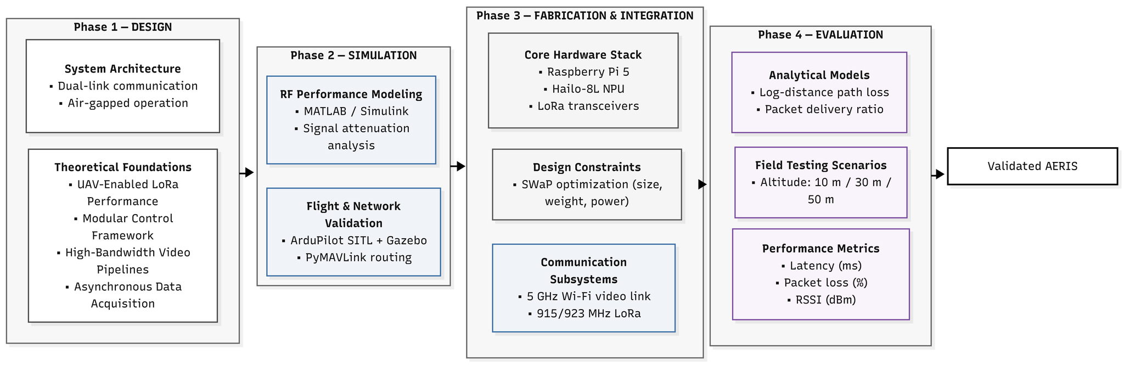
Figure 3.1 Operational Workflow of AERIS
The flowchart illustrates the four-stage operational lifecycle of the AERIS system, beginning with a Design phase that establishes an air-gapped, dual-link architecture grounded in theoretical foundations like UAV-enabled LoRa performance, modular control frameworks, and asynchronous data acquisition. This is followed by a Simulation stage where high-fidelity MATLAB/Simulink modeling and ArduPilot SITL/Gazebo environments are used to audit flight mechanics and PyMAVLink routing, ensuring network integrity and signal attenuation analysis before physical deployment.
The workflow then transitions to Fabrication and Integration, where the core hardware stack—comprising a Raspberry Pi 5 and Hailo-8L NPU—is assembled under strict SWaP (Size, Weight, and Power) constraints. This stage physically segregates the communication subsystems into a 5GHz Wi-Fi link for high-bandwidth video and a 915/923MHz LoRa link for resilient telemetry. Finally, the Evaluation phase employs analytical tools like Log-distance path loss models to measure latency, packet loss, and RSSI across stratified altitudes (10m–50m). This rigorous process ensures a Validated AERIS platform capable of reliable, off-grid survivor monitoring in post-disaster environments
- Data Telemetry and Transmission Flowchart
As shown in figure 3.2, the system uses dual-link architecture composed of a 5 GHz Wi-Fi link for high-bandwidth video and a 915/923 MHz LoRa link for reliable telemetry. This separation ensures continuous operation even when one communication channel is degraded.
The AERIS architectural framework utilizes a heterogeneous dual-link communication system designed to facilitate the concurrent transmission of low-latency telemetry and high-bandwidth visual intelligence from an onboard Raspberry Pi 5 to a decentralized Ground Control Station (GCS). To ensure operational stability under strict Size, Weight, and Power (SWaP) constraints, the system employs logical network segregation, bifurcating data into two parallel transmission pipelines.
The telemetry pipeline is the high-reliability backbone; it aggregates AI-processed metadata—generated via Late Sensor Fusion on the Hailo-8L NPU—and utilizes PyMavlink middleware to serialize combined MAVLink packets. These packets are transmitted over a Point-to-Point (P2P) 915/923 MHz link using Ebyte E220/E32 LoRa modules paired with a vertically oriented omnidirectional whip antenna to maximize RF isolation.

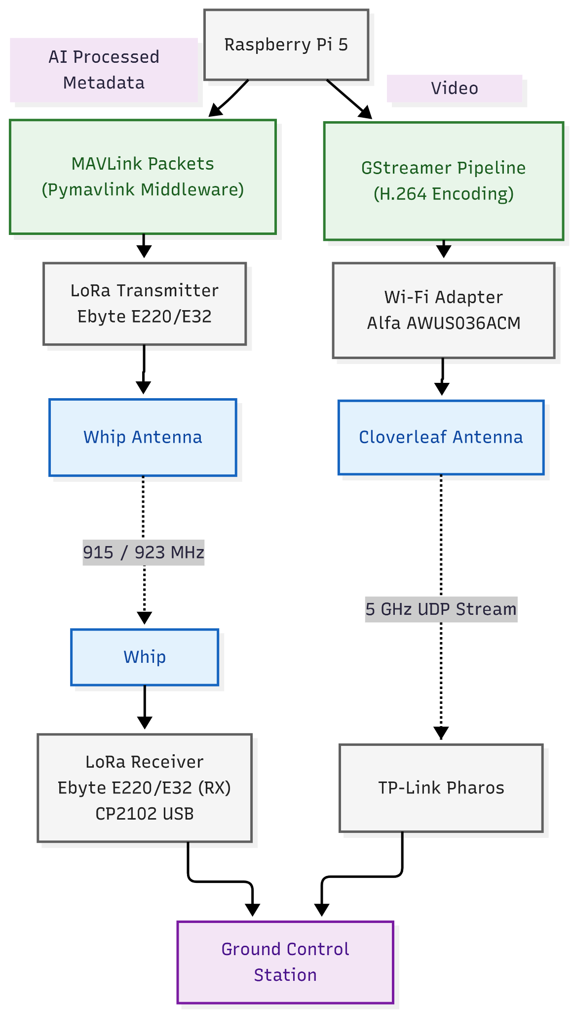
Figure 3.2 Data Telemetry and Transmission Flowchart of AERIS
Concurrently, the surveillance pipeline handles high-definition visual intelligence. Raw feeds from the dual-sensor payload (RGB/Thermal) are compressed via a GStreamer pipeline using hardware-accelerated H.264 encoding, reducing raw data volumes to a manageable 5–6 Mbps. This data is streamed via the User Datagram Protocol (UDP) over a 5 GHz link using an Alfa AWUS036ACM Wi-Fi adapter and a circularly polarized cloverleaf antenna, which prevents signal dropouts during high-mobility maneuvers.
At the receiving end, a ground-side LoRa module, integrated via a CP2102 USB-to-TTL adapter, captures telemetry, while a tripod-mounted TP-Link Pharos directional antenna intercepts the 5 GHz video stream. Both links converge at the GCS dashboard, which utilizes asynchronous background threading to provide the operator with synchronized, real-time access to flight metrics, JavaScript Object Notation (JSON) survivor alerts, and live video for Human-in-the-Loop (HITL) verification.

Hardware Design and Structural Configuration
- 3D Model and Antenna Placement Optimization
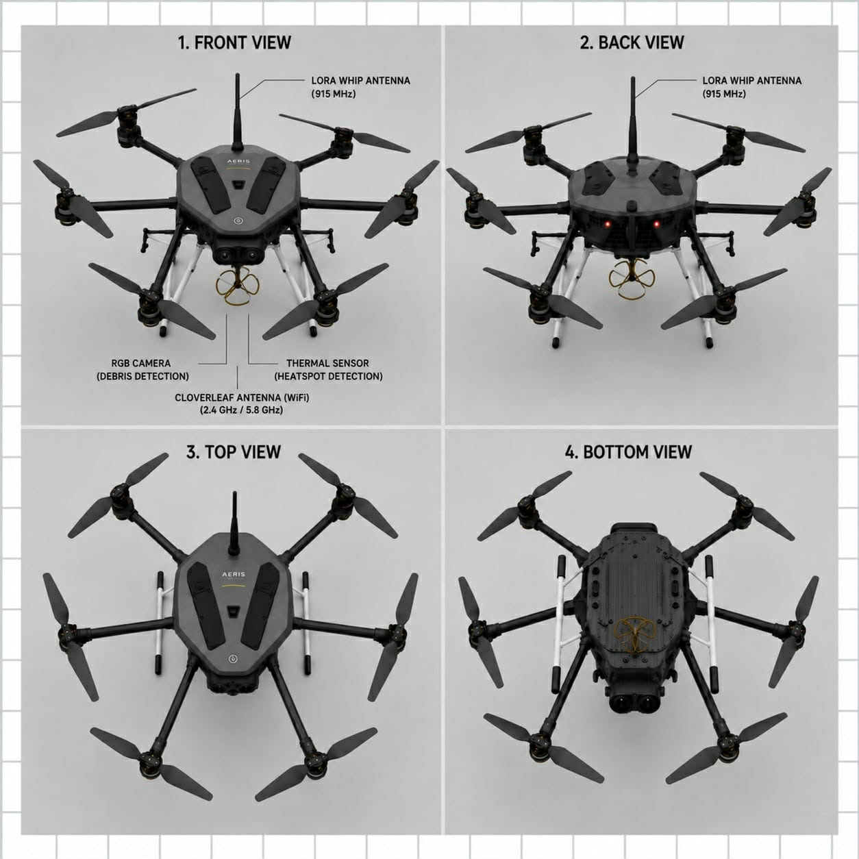
Figure 3.3 AERIS Prototype 3D Design
Figure 3.4 Back View of AERIS Prototype 3D Design
Figure 3.5 Top View of AERIS Prototype 3D Design
Figure 3.6 Bottom View of AERIS Prototype 3D Design
The AERIS platform is designed around a hexacopter configuration to serve as the primary aerial vehicle, a choice necessitated by the need to manage the substantial weight of the specialized Edge Artificial Intelligence (Edge AI) payload while strictly adhering to Size, Weight, and Power (SWaP) constraints. This six-motor architecture provides the necessary lift and stability to carry the Intelligence & Communications (I&C) pod, which is housed in a custom 3D-rendered enclosure crafted from high-durability Polyethylene Terephthalate Glycol (PETG) filament. To preserve flight dynamics and maximize battery-to-payload efficiency, the enclosure is mounted rigidly beneath the drone's primary center frame plate using a Center of Gravity (CG) alignment technique. This placement ensures that the auxiliary payload weight does not create asymmetrical torque on the Brushless Direct Current (BLDC) motors, which would otherwise lead to mid-flight instability or premature battery depletion.
The geometric positioning of the antenna arrays on this chassis is optimized to minimize Electromagnetic Interference (EMI) and signal shadowing through the following justifications:
RF Isolation and Frequency Segregation: To maximize Radio Frequency (RF) isolation and prevent "swamping" or cross-frequency interference, the antennas are physically separated on opposite sides of the 3D-printed housing. This separation is vital for maintaining the integrity of the heterogeneous dual-link architecture, which simultaneously manages a 5 Gigahertz (GHz) high-bandwidth Wi-Fi link and a 915/923 Megahertz (MHz) low-bandwidth Long Range (LoRa) link.
Minimizing Signal Shadowing: The sub-GHz linear polarization whip antenna for the LoRa telemetry link extends vertically away from the drone's carbon fiber arms. This vertical orientation is specifically intended to mitigate signal attenuation (reduction in strength) caused by the conductive carbon fiber frame, ensuring that mission-critical Micro Air Vehicle Link (MAVLink) telemetry maintains its reported 97.5% Packet Delivery Ratio (PDR).
Directional Alignment for Video: In contrast, the circularly polarized cloverleaf antenna dedicated to the Wi-Fi video stream is directed downward. This orientation ensures a continuous Line-of-Sight (LoS) with the Ground Control Station (GCS) tracking array, preventing signal dropouts during high-mobility maneuvers like pitching and rolling.
EMI Mitigation: By placing the high-power Wi-Fi transmitter and the sensitive LoRa receiver at the maximum allowable distance permitted by the chassis, the system naturally attenuates interfering signals. This ensures that the high-power video stream does not disrupt the asynchronous JavaScript Object Notation (JSON) alert coordinates and GPS metadata being transmitted to the ground.
Through this rigorous optimization of the 3D model and antenna placement, the AERIS system effectively bypasses the signal degradation common in infrastructure-denied zones, providing a reliable, infrastructure-independent "communication bubble" for rescue operations.

- Component Selection and Material Specifications
To achieve the primary objectives of this study—specifically, executing real-time edge-based target detection and maintaining resilient communications in infrastructure-denied environments—a precise hardware ecosystem was carefully curated. The selection of these Commercial Off-The-Shelf (COTS) components and specialized materials is strictly governed by Size, Weight, and Power (SWaP) constraints, radio frequency isolation, and aerodynamic stability requirements.
Rather than relying on a single communication pipeline that could easily be saturated or obstructed, the chosen components establish a heterogeneous dual-link network. This system architecture is designed to safely carry the necessary processing payload while logically isolating heavy data traffic from critical telemetry. By doing so, the aerial platform can dynamically execute autonomous search missions, process complex computer vision models locally at the edge, and maintain a highly reliable, low-latency data link with the ground control station under challenging operational conditions.
The following sections detail the specific technical specifications, electrical properties, and geometric justifications for each component selected to fulfill the requirements of this study.
- COTS UAV Procurement
A Commercial Off-The-Shelf (COTS) UAV serves as the primary autonomous aerial platform for the AERIS system, providing the necessary structural framework and propulsion for search missions. This study utilizes a custom-configured aircraft to support a dual-link communication payload while adhering to strict optimization constraints. Managed by ArduPilot firmware, the platform enables autonomous waypoint navigation, allowing researchers to empirically evaluate network performance and validate system resilience in infrastructure-denied environments.
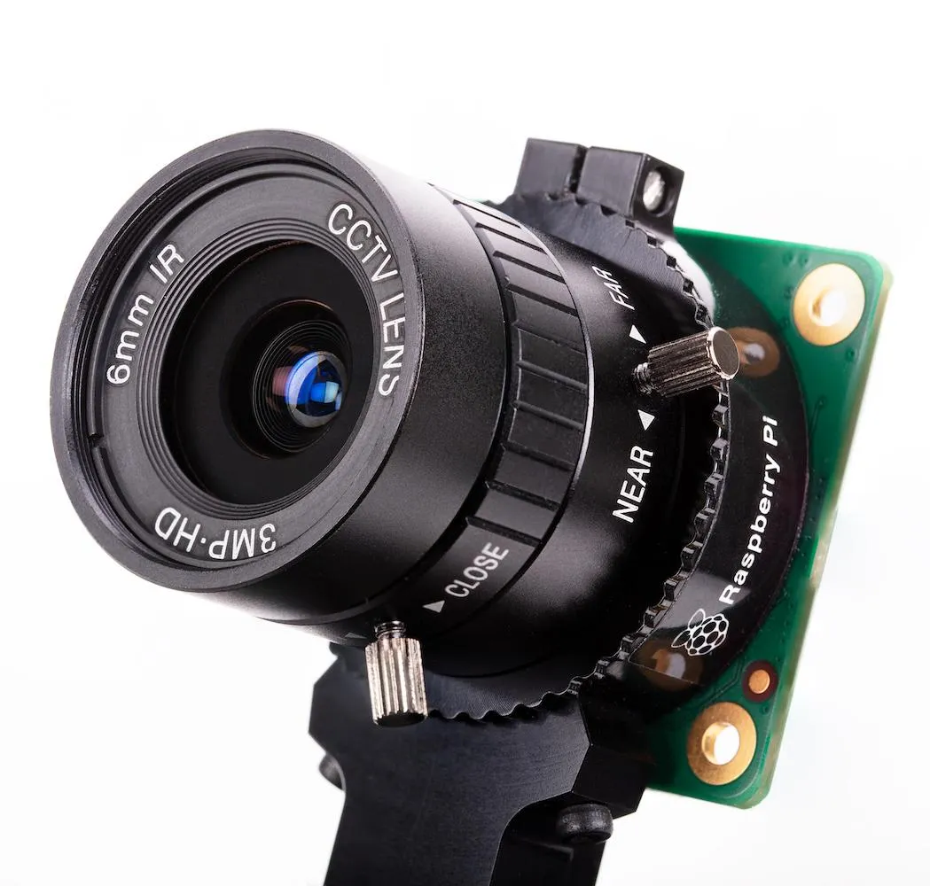
- Raspberry Pi Camera (RGB Camera)
The RGB camera serves as the primary heavy-data generator, capturing high-resolution video (1080p at up to 30 fps, or 720p at 60 fps) to simulate massive network traffic and stress-test the 5GHz Wi-Fi link. Rigidly mounted at a 45-degree oblique downward angle, the sensor provides an optimal slant range for the NPU to analyze the full geometric profile of human targets, improving detection accuracy over traditional nadir views.
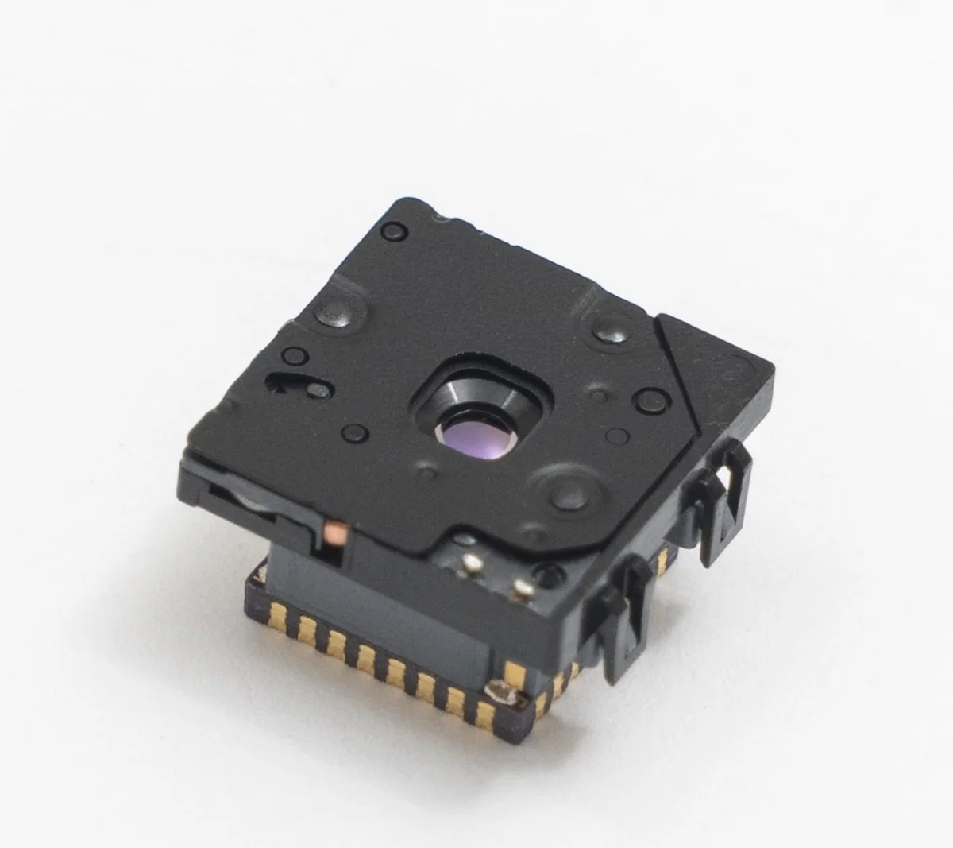
- FLIR LEPTON 3.5 (Thermal Camera)
The Forward-Looking Infrared (FLIR) sensor, which captures radiometric heat signatures at 160x120 thermal pixels, functions as the secondary data-generation tool, continuously outputting thermal matrices to the central processor. The sensor is co-located with the RGB camera and pitched at a fixed oblique angle to ensure the thermal and visual frames perfectly overlap, providing the critical environmental contrast needed by the onboard Neural Processing Unit (NPU) to isolate human heat signatures and generate low-latency text alerts for the sub-GHz telemetry link.
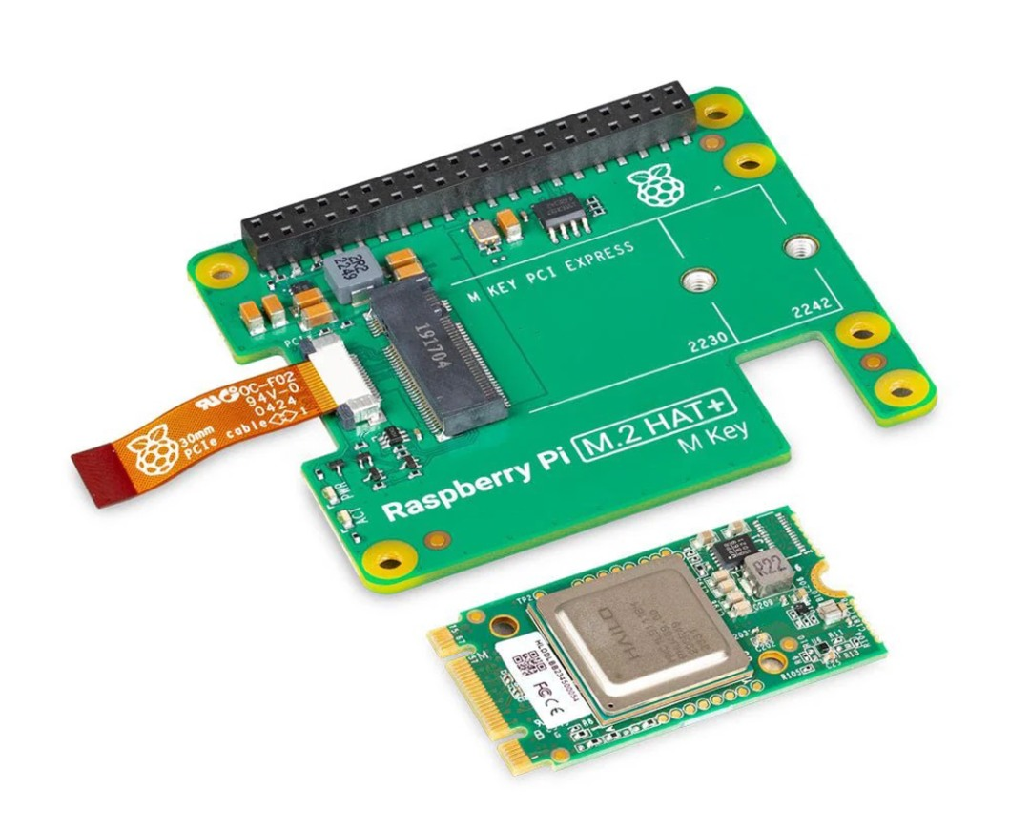
- Hailo-8L Neural Processing Unit (NPU)
The Hailo-8L is a specialized edge-based machine learning accelerator designed to bypass cloud latency by executing optimized target detection models directly at the edge. The NPU ingests raw feeds from the dual cameras, including radiometric heat signatures at 160x120 thermal pixels, and runs YOLOv8 inferences locally to act as a data-trigger mechanism. Upon mathematically confirming a target match, it generates a microscopic survivor alert string, effectively reducing megabytes of pixel data into lightweight binary metadata for resilient transmission via the sub-GHz telemetry link.
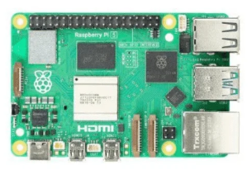
- Raspberry Pi 5 (Single Board Computer)
The Raspberry Pi 5 serves as the central processing unit and data router for the AERIS network, coordinating the flow of multi-spectral information between the onboard sensors, the NPU, and the dual-link transmission modules. By managing hardware interfaces and software middleware, it ensures that telemetry and surveillance data are logically segregated and efficiently routed to maintain real-time system performance.

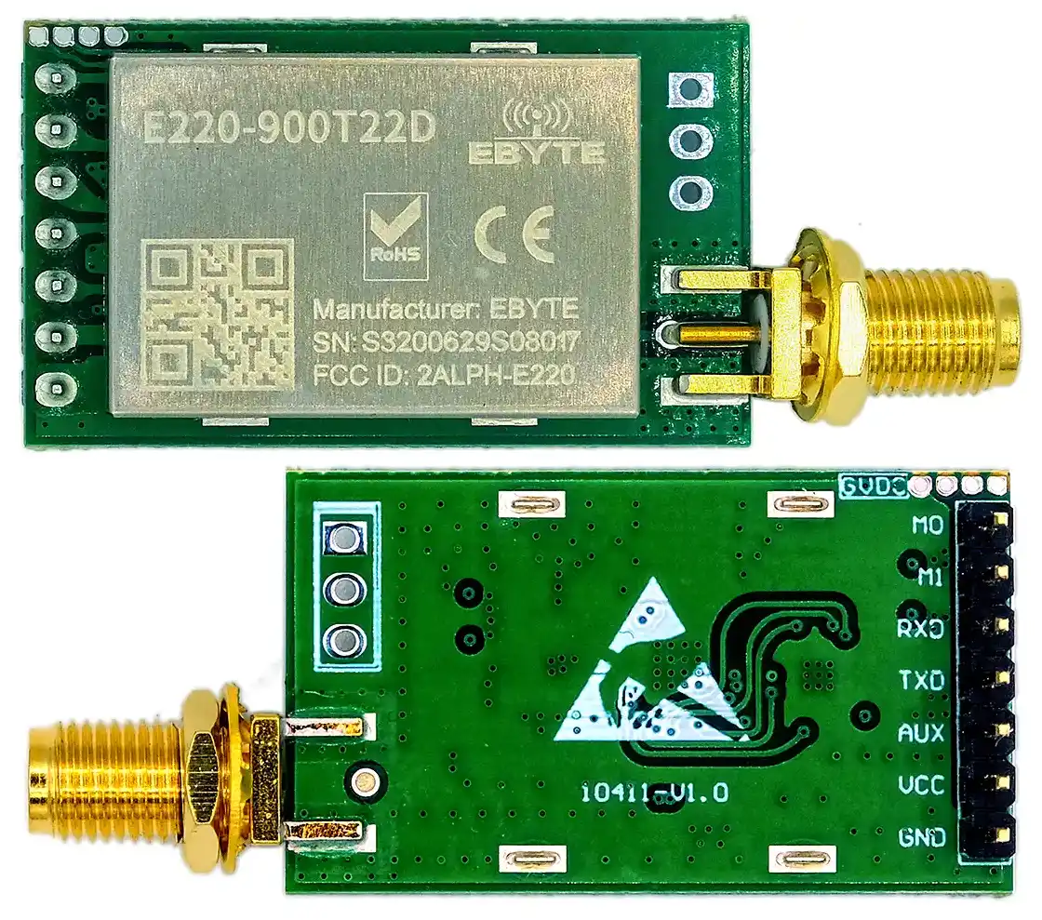
- Ebyte E220/E32 (LoRa Transceiver Module)
The Ebyte LoRa modules form the low-bandwidth, resilient backbone of the dual-link network on the 915/923 MHz band, establishing a Point-to-Point serial link between the drone and the Ground Control Station (GCS). The ground-side module, integrated via a serial adapter, asynchronously processes mission-critical MAVLink telemetry and JSON alert coordinates, ensuring situational awareness even if the high-bandwidth video stream is lost.
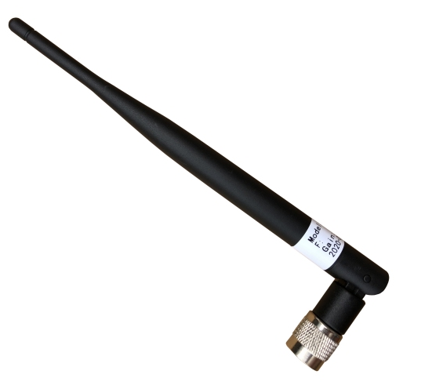
- Sub-GHz Omnidirectional Whip Antenna
The sub-Gigahertz omnidirectional whip antenna is the physical interface for the platform's Long Range telemetry link, operating on a lower frequency band specifically chosen for its superior ability to penetrate dense obstacles like debris and canopies. Its mounting position is optimized to ensure maximum signal integrity by minimizing shadowing from the drone's carbon fiber frame and maximizing RF isolation from the high-power video stream. The antenna functions as the high-reliability backbone of the dual-link architecture, transmitting mission-critical packets containing real-time location data and survivor detection alerts directly to the Ground Control Station for operator verification.
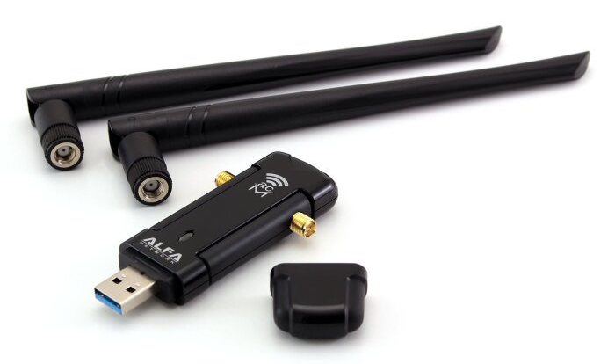
- Alfa AWUS036ACM (5GHz Wi-Fi Module)
The AERIS platform utilizes a high-power external USB Wi-Fi adapter as a dedicated transceiver for its high-bandwidth surveillance layer, establishing a 5 GHz Point-to-Point link to the Ground Control Station. Integrated via the Raspberry Pi 5 and housed in a stabilized 3D-printed enclosure, the module facilitates the real-time streaming of compressed thermal and visual video using hardware-accelerated encoding and the User Datagram Protocol. This configuration, paired with downward-directed circularly polarized antennas, ensures low-latency data delivery and maintains link stability during high-mobility maneuvers in infrastructure-denied disaster zones.

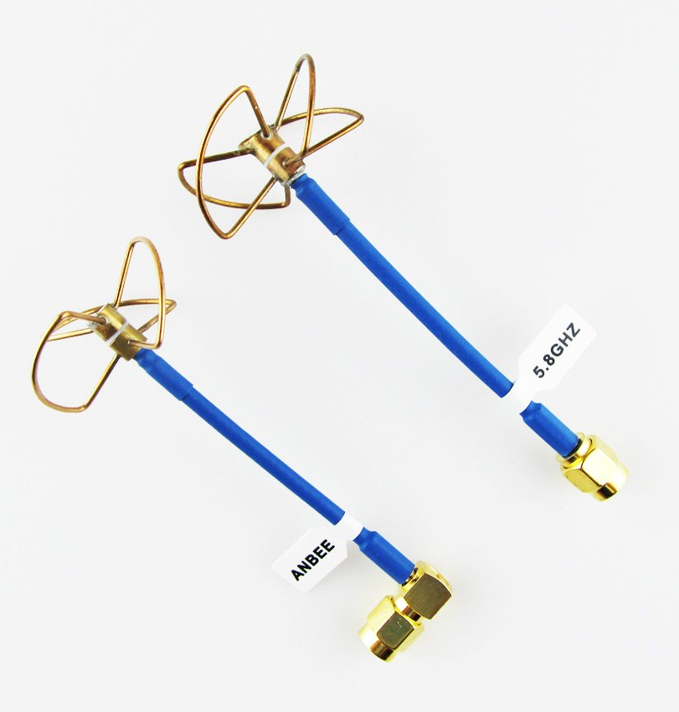
- 5GHz Cloverleaf Antenna (Circular Polarization)
The cloverleaf antenna is a fundamental component of the high-power video link. It uses circular polarization to ensure a continuous and stable high-definition feed, preventing signal dropouts during high-mobility flight maneuvers essential for Human-in-the-Loop monitoring. To ensure optimal performance, the antenna is physically positioned for maximum RF isolation from the other communication link and is directed downward to maintain clear Line-of-Sight with the Ground Control Station. The integrity of this physical link is maintained through a strict maintenance framework to ensure the video stream reaches the GCS without critical packet loss even as the aerial platform increases its range.
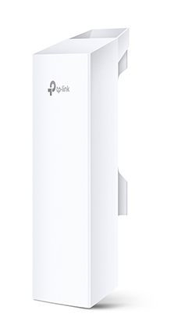
- TP-Link Pharos High-Gain Directional Antenna (GCS)
The TP-Link Pharos High-Gain Directional Antenna serves as the primary receiving node at the Ground Control Station (GCS) for the 5 GHz high-bandwidth network. Unlike the drone’s omnidirectional antenna, this directional unit concentrates Radio Frequency reception into a focused beam width to maximize Line-of-Sight (LoS) link gain and actively mitigate Free Space Path Loss (FSPL). This configuration ensures that heavy, real-time visual streams remain stable even when the drone is at a distance. By connecting the received data directly to the GCS laptop, the system creates a "zero-buffer pipeline" for incoming intelligence, allowing researchers to quantitatively evaluate the network's reliability and transmission latency in challenging environments.

Phase I: Network Architecture and Mathematical Modeling
This phase focuses on theoretical validation using mathematical models. It ensures that the system meets communication requirements before physical implementation.
- Mathematical Formulations
Prior to the physical fabrication of the AERIS architecture, the proposed heterogeneous dual-link communication network will undergo rigorous theoretical validation through mathematical modeling. This phase will establish the baseline Radio Frequency (RF) performance, ensuring that both the 5GHz high-bandwidth video downlink and the 915MHz sub-GHz telemetry link possess sufficient link margins to operate reliably within the targeted 10m to 200m disaster response perimeter.
- Link Budget Analysis
The communication system uses dual-link architecture supported by link budget analysis, path loss models, and channel capacity equations. These ensure sufficient signal strength, reliability, and bandwidth allocation.
To verify that the transmitted signals will successfully reach the Ground Control Station (GCS) with sufficient power to be decoded, a comprehensive Link Budget Analysis will be formulated for both frequency bands. The received power will be mathematically defined as:
$$P_{RX}=P_{TX}+G_{TX}-L_{TX}-PL+G_{RX}-L_{RX}$$
Where $P_{RX}$ is the total received power (in dBm), $P_{TX}$ is the transceiver output power, $G_{TX}$ and $G_{RX}$ represent the respective isotropic antenna gains (in dBi), $L_{TX}$ and $L_{RX}$ account for hardware insertion losses, and $PL$ represents the total path loss. The calculated $P_{RX}$ must maintain a Fade Margin of at least 10 dB to 15 dB above the absolute receiver sensitivity $S_{RX}$ to be considered valid.

- Payload and Weight Analysis
Payload analysis is conducted to evaluate the total mass of all onboard components and verify compatibility with the UAV’s maximum payload capacity to ensure stable and safe flight operation. The total payload weight is determined by summing the individual masses of all integrated components:
$$W_{\text{total}}=\sum_{i=1}^{n}{W_{i}}$$
where $W_{\text{total}}$represents the total payload weight and $W_{i}$denotes the weight of each component. This value is compared against the UAV’s maximum allowable payload $W_{\text{max}}$to ensure:
$$W_{\text{total}}<W_{\text{max}}$$
To enhance operational safety and prevent system overload, a factor of safety (FoS) is applied to account for uncertainties such as dynamic load variations, battery fluctuations, and structural stress during flight:
$$FoS=\frac{W_{\text{max}}}{W_{\text{total}}}$$
A minimum FoS greater than 1 (typically ≥ 1.2–1.5) is maintained to ensure sufficient lift margin. Additionally, the thrust-to-weight ratio is considered to verify that the propulsion system can sustain flight:
$$\frac{T}{W}≥2$$
where $T$is the total thrust produced by the motors and $W$is the total system weight. Maintaining an adequate thrust-to-weight ratio ensures stable lift, maneuverability, and system reliability during operation.
Through these calculations, the payload analysis guarantees that the UAV operates within safe limits while maintaining structural stability and consistent flight performance under varying mission conditions.
- Power Consumption and Endurance Analysis
Power consumption of the system is determined by calculating the total current draw of all onboard components and using this value to estimate battery capacity and overall system endurance. The total current consumption is obtained by summing the individual current requirements of each component:
$$I_{\text{total}}=\sum_{i=1}^{n}{I_{i}}$$
where $I_{\text{total}}$is the total system current (A or mA) and $I_{i}$represents the current draw of each component such as the Raspberry Pi, NPU, cameras, and communication modules.
The total power consumption of the system is then calculated using:
$$P=V×I_{\text{total}}$$
where $P$is the total power (Watts), $V$is the supply voltage, and $I_{\text{total}}$is the total current.
To determine the required battery capacity, the following relation is used:
$$C_{\text{required}}=I_{\text{total}}×t_{\text{desired}}$$
where $C_{\text{required}}$is the battery capacity (mAh or Ah) and $t_{\text{desired}}$is the target operating time.
The estimated system endurance or operating time is computed as:
$$t=\frac{C_{\text{battery}}}{I_{\text{total}}}$$
where $t$is the operating time (hours), and $C_{\text{battery}}$is the available battery capacity.
To ensure battery longevity and safe operation, the effective usable capacity is adjusted based on the Depth of Discharge (DoD):
$$t_{\text{actual}}=\frac{C_{\text{battery}}×\text{DoD}}{I_{\text{total}}}$$
Through these calculations, the system ensures that sufficient power is supplied to all components while maintaining reliable operation for the required mission duration.

- Detection System Design
The detection subsystem integrates an RGB camera and a thermal imaging sensor with a YOLOv8-based object detection model to enable robust multi-modal survivor detection under varying environmental conditions. The fusion of visual and thermal data enhances detection reliability, particularly in low-visibility or obstructed disaster scenarios.
The performance of the detection system is quantitatively evaluated using standard classification metrics derived from the confusion matrix. These include accuracy, precision, recall, and false positive rate, defined as follows:
$$\text{Accuracy}=\frac{TP+TN}{TP+TN+FP+FN} \\ \text{Precision}=\frac{TP}{TP+FP} \\ \text{Recall}=\frac{TP}{TP+FN} \\ \text{False Positive Rate (FPR)}=\frac{FP}{FP+TN}$$
where $TP$(True Positives) represents correctly detected human targets, $TN$(True Negatives) represents correctly identified non-targets, $FP$(False Positives) represents incorrect detections, and $FN$(False Negatives) represents missed detections.
In addition, the overall detection performance can be summarized using the F1-score, which balances precision and recall:
$$F1=2⋅\frac{\text{Precision}⋅\text{Recall}}{\text{Precision}+\text{Recall}}$$
To assess real-time capability, the detection latency is measured as:
$$t_{\text{detect}}=t_{\text{output}}-t_{\text{input}}$$
where $t_{\text{input}}$is the time a frame is captured and $t_{\text{output}}$is the time the detection result is generated.
Through these evaluation metrics, the system ensures that the detection subsystem is not only accurate but also responsive and reliable for real-time search and rescue operations in post-disaster environments.
- Security Architecture
To ensure secure and reliable data transmission, the system implements cryptographic security mechanisms including AES-128 or ChaCha20 symmetric encryption, combined with MAVLink-based authentication and validation protocols. These mechanisms protect the integrity, confidentiality, and authenticity of transmitted telemetry and survivor data in hostile or unsecured disaster environments.
The encryption process transforms plaintext data ($P$) into ciphertext ($C$) using a secret key ($K$):
$$C=E_{K}(P)$$
and the corresponding decryption process retrieves the original data:
$$P=D_{K}(C)$$
For AES-128, encryption is performed using a series of substitution and permutation operations across 128-bit blocks, structured as:
$$C=AES_{K}(P)$$
where $K$is a 128-bit encryption key. Similarly, ChaCha20 employs a stream cipher approach, generating a keystream ($KS$) which is XORed with the plaintext:
$$C=P⊕KS$$
where $⊕$denotes the XOR operation.
To ensure data integrity and authentication, a Message Authentication Code (MAC) or hash-based verification is applied:
$$MAC=H(K∣∣M)$$
where $H$is a cryptographic hash function, $K$is the secret key, and $M$is the message. The receiver recomputes the MAC to verify that data has not been altered during transmission.
Additionally, MAVLink packets are validated through checksum verification:
$$\text{Checksum}=f(\text{packet data})$$
ensuring that corrupted or tampered packets are detected and discarded.
Through the integration of encryption, authentication, and integrity verification, the system ensures secure communication, protects sensitive survivor data, and mitigates potential cyber threats during disaster response operations.

- Path Loss Modeling for Disaster Environments
To calculate the total path loss ($PL$) required for the Link Budget, the system will initially utilize the Friis Transmission Equation to model the theoretical Free Space Path Loss (FSPL) in an ideal, unobstructed environment:
$$FSPL(dB) = 20log_{10}(d)+20log_{10}(f)+32.44$$
Where $d$ represents the distance in kilometers and f represents the frequency in MHz. However, because AERIS will operate in disaster environments characterized by concrete rubble and obstructed Line-of-Sight (LoS), the ideal FSPL is insufficient. Therefore, the architectural model will incorporate the Log-Distance Path Loss Model to account for environmental shadowing and multipath fading:
$$PL(d)=PL(d_{0})+10nlog_{10}(\frac{d}{d_{0}})+X_{σ}$$
Where $PL(d_{0})$ is the path loss at a reference distance, $n$ is the path loss exponent corresponding to the density of the disaster debris, and $X_{σ}$ is a zero-mean Gaussian random variable representing shadowing effects. This model will mathematically demonstrate how the 915MHz LoRa link maintains integrity as a telemetry anchor even when the 5GHz link undergoes severe environmental attenuation.
- Channel Capacity and SNR Resilience
To theoretically mandate the physical decoupling of the dual-link architecture, the Shannon-Hartley Theorem will be applied:
$$C=Blog_{2}(1+\frac{S}{N})$$
Where $C$ defines the maximum channel capacity (in bits per second), $B$represents the channel bandwidth (in Hertz), and $\frac{S}{N}$ is the linear Signal-to-Noise Ratio (SNR). This formulation will mathematically justify the bandwidth allocation strategy: it mandates intentionally constraining the bandwidth of the 915MHz LoRa link to maximize SNR resilience for critical telemetry, while allocating massive wideband capacity to the 5GHz Wi-Fi link to support the video payload, accepting a proportionally lower SNR at extended ranges.
- Rate-Distortion Theory and Throughput Limits
While the Shannon-Hartley theorem defines the maximum capacity of the 5GHz link, the vision subsystem will generate raw multi-megapixel video that exceeds standard RF throughput. To mathematically validate the transmission line's capacity, Rate-Distortion Theory will be utilized. This information theory framework evaluates the fundamental trade-off between the transmission bit rate ($R$) and the resulting image distortion ($D$):
$$R(D)=min_{E[d(X,\hat{X})]≤D}I(X;\hat{X})$$
By applying this theoretical limit, the researchers will calculate the optimal compression ratio for the H.264 hardware-accelerated codec. This will prove mathematically that the raw video data can be compressed into a target bit rate (5-6 Mbps) that safely traverses the 5GHz bandwidth limits, without introducing severe compression artifacts that would cause the localized YOLOv8 object detection algorithms to fail.

- Network Architecture Design
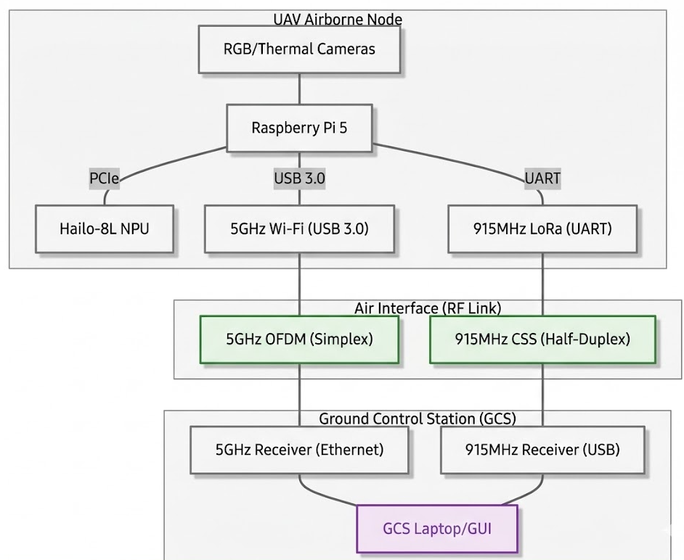
Figure 3.7 AERIS Network Architecture Design
Following the mathematical validation of the link budgets, a comprehensive Data Link Layer and Radio Frequency (RF) structural topology will be synthesized to map the hardware interfaces and transmission pathways. This block diagram will serve as the physical and logical blueprint for the AERIS architecture, strictly delineating the heterogeneous dual-link networks across OSI Layer 1 (Physical) and OSI Layer 2 (Data Link).
- UAV Node and Internal Bus Topology
The architectural diagram will first map the localized hardware interfaces within the UAV node. It will graphically define the sensor data ingestion pathways (MIPI CSI-2 and SPI) routing into the central Raspberry Pi 5. Furthermore, the diagram will establish the bi-directional PCIe Gen 2.0 interface connecting the central processor to the Hailo-8L Neural Processing Unit (NPU), visually representing the hardware acceleration loop. Finally, it will trace the segregated output pathways, illustrating the serialized telemetry routing to the LoRa module via the UART GPIO pins, while the uncompressed video payload routes to the Wi-Fi module via the USB 3.0 bus.
- The RF Air Interface
The core of the network architecture design will focus on mapping the physical air interface between the UAV and the Ground Control Station (GCS). The topology will visually separate the two RF links to demonstrate the absence of intra-system interference. The 5GHz Wi-Fi link will be mapped as a high-bandwidth, unidirectional (Simplex) downlink utilizing Orthogonal Frequency-Division Multiplexing (OFDM). Parallel to this, the 915MHz LoRa link will be mapped as a low-bandwidth, bidirectional (Half-Duplex) transceiver link utilizing Chirp Spread Spectrum (CSS) modulation, demonstrating its dual role as both a telemetry downlink and a command uplink.
- GCS Node and Hardware Deserialization
The final segment of the structural diagram will map the ground-based reception topology. It will detail the physical routing of the captured RF signals from the respective ground antennas into the GCS hardware. This includes mapping the RJ45 Gigabit Ethernet interface for the 5GHz video pipeline and the CP2102 USB-to-UART bridge for the 915MHz telemetry link. This comprehensive topology will validate the physical separation of the data streams from the moment of sensor capture on the UAV to the final graphical rendering on the GCS interface.

Phase II: System Simulation and Validation
Simulation validates system behavior using SITL and MATLAB environments before real deployment. It focuses on communication and data transmission performance.
Integrated SITL and Kinematic Environment Setup
The software-level verification phase initiates with the deployment of an ArduPilot Software-in-the-Loop (SITL) environment paired with the Gazebo robotics engine to replicate the 3D physics and environmental constraints of a post-disaster zone. This setup replicates the behavior of the ArduPilot flight firmware, allowing the study to audit the low-level flight mechanics and virtual telemetry routing prior to real-world deployment. By virtualizing the hardware stack, the simulation emulates the UART serial communication bridge between the flight controller and the Raspberry Pi 5 companion computer, utilizing high baud rates (921,600) to ensure high-speed data exchange without buffer overflows. This kinematic sandbox is essential for verifying that the aircraft’s center-of-gravity alignment and motor stabilization remain consistent during the high-intensity data processing workloads triggered by the onboard Edge AI.
Telemetry Middleware and Video Protocol Modeling
To ensure infrastructure independence, the simulation validates the PyMAVLink middleware as the primary data broker for the airborne system. This phase programmatically tests the binary serialization efficiency of the MAVLink protocol, converting system states into a streamlined stream of bytes that is significantly lighter than text-based formats like JSON. The simulation focuses on parsing critical GLOBAL_POSITION_INT packets for GNSS coordinates, ensuring that mission-critical metadata is successfully routed through the simulated 915/923MHz LoRa link in "transparent mode". Simultaneously, the surveillance layer is validated using a GStreamer pipeline over User Datagram Protocol (UDP). This modeling prioritizes "data freshness" by utilizing hardware-accelerated H.264 encoding to reduce raw 200 Mbps video feeds to a manageable 5–6 Mbps pipeline, accepting occasional frame skips to avoid the cumulative latency of retransmission.
RF Signal Propagation and Network Reliability Modeling
While SITL manages flight logic, MATLAB/Simulink is utilized for high-fidelity numerical modeling of the decentralized communication link’s reliability. The simulation implements the Friis Transmission Equation and the Log-Distance Path Loss Model to account for environmental signal attenuation caused by shadowing and multipath fading in complex disaster topographies. By using telemetry data from the SITL tests as input seeds, the MATLAB workspace calculates Received Signal Strength Indicator (RSSI) degradation curves over radial distances of 10m, 50, 100m, 150m, and 200m, then stratified altitudes of 10m, 30m, and 50m. This mathematical evaluation ensures the architecture maintains its target 97.5% Packet Delivery Ratio (PDR), verifying that the 915/923MHz LoRa link remains a reliable anchor for survivor coordinates even when the 5GHz surveillance layer experiences bandwidth saturation.
Pre-Deployment Verification and Mission Handshake SOP
The simulation concludes with a rigorous Standard Operating Procedure (SOP) for mission authorization, established through a mandatory algorithmic handshake. A constant 1Hz MAVLink "heartbeat" message exchange is enforced to confirm persistent state synchronization between the simulated aircraft and the localized Ground Control Station (GCS). Before the system is permitted to transition into autonomous GUIDED mode, the simulation mandates a comprehensive parameter synchronization audit. This automated pre-flight check verifies that the virtual UAV has achieved a precise GPS lock and that battery thresholds are within safe discharge limits relative to the combined drain of the propulsion system and the Hailo-8L NPU. This final verification ensures that all pre-flight failsafes are active and that the decentralized data routing framework is fully synchronized for off-grid deployment.

Phase III: Hardware Integration and Embedded System Prototyping
This phase integrates all components into a functional prototype and ensures compatibility under physical and power constraints.
- Vision Subsystem and Dataset Pipeline
The AERIS vision subsystem aggregates a standard Raspberry Pi RGB camera and a FLIR Lepton 3.5 radiometric thermal sensor into a unified, forward-facing hardware mount. This embedded prototype focuses on power distribution, hardware interface protocols, and algorithmic raw data synchronization prior to hardware acceleration.
  - Physical Integration and Power Regulation
This phase integrates all system components into a fully functional prototype while ensuring compatibility under physical, electrical, and power constraints. The integration process involves combining the sensing, processing, communication, and power subsystems into a unified UAV platform, ensuring that all components operate cohesively without performance degradation.
To verify system compatibility, the overall system load is evaluated in terms of both weight and power requirements, ensuring that the integrated system operates within allowable limits. The total system weight is expressed as:
$$W_{\text{total}}=\sum_{i=1}^{n}{W_{i}}$$
and must satisfy the condition:
$$W_{\text{total}}≤W_{\text{max}}$$
where $W_{\text{max}}$is the UAV’s payload capacity.
Similarly, power compatibility is assessed using total current consumption:
$$I_{\text{total}}=\sum_{i=1}^{n}{I_{i}}$$
and total power demand:
$$P_{\text{total}}=V×I_{\text{total}}$$
to ensure that the power supply system can sustain all components during operation without voltage drops or system instability.
To maintain system reliability, proper voltage regulation is applied, ensuring that the operating voltage satisfies:
$$V_{\text{out}}≈V_{\text{required}}$$
across all components through regulated power modules such as UBECs.
Through the application of these constraints and validation procedures, the integration phase ensures that the prototype operates efficiently, maintaining structural stability, electrical compatibility, and continuous operation under real deployment conditions.

  - Sensor Interface Protocols
Because the dual sensors capture different electromagnetic spectrums, they utilize distinct hardware interfaces to communicate with the Raspberry Pi 5. The high-resolution RGB camera connects directly via the high-speed MIPI CSI-2 port to offload image processing to the VideoCore processor, enabling high-frame-rate capture without burdening the primary CPU. Conversely, the FLIR Lepton 3.5 thermal module integrates using a dual-protocol approach: a simple, two-wire I2C interface handles low-bandwidth command and control telemetry, while a full-duplex, high-speed synchronous SPI bus efficiently streams the dense, real-time radiometric thermal matrices.
  - Frame Synchronization and Tensor Pre-Processing
Once connected, the Raspberry Pi 5 pipeline ingests and synchronizes data from the dual-sensor array: a high-resolution RGB camera and a FLIR Lepton 3.5 thermal camera. Co-located at a 45-degree oblique angle to capture an overlapping slant range, the sensors provide the geometric profiles and heat contrast needed to isolate human targets. To handle frame-rate discrepancies, the Raspberry Pi 5 uses internal RAM buffering to timestamp and pair incoming frames. Finally, both matrices undergo pixel normalization and resolution scaling into the strict tensor dimensions required for Edge AI evaluation, enabling the generation of low-latency text alerts for the sub-GHz telemetry link.
- Edge AI Processing Unit (Data Processing Phase 1)
The AERIS Edge AI Processing Unit pairs a Raspberry Pi 5 with a Hailo-8L NPU to run YOLOv8 models offline. Providing up to 13 TOPS, the NPU executes dual-network inference for multi-spectral target detection, reducing high-bandwidth visual and thermal payloads into lightweight metadata (e.g., GPS coordinates and target flags). This data is serialized via PyMavlink into binary-efficient MAVLink packets for transmission over a narrow-band, sub-GHz LoRa telemetry link. Compressing raw data into optimized alerts maintains mission-critical situational awareness even when high-frequency channels are obstructed.
  - Dataset Lineage and Localized Inferencing
To strictly adhere to the infrastructure-independent, "air-gapped" requirements of the study, the Edge AI processing unit operates entirely offline, using highly optimized, quantized YOLOv8 object detection models pre-loaded onto the Hailo-8L NPU. Prior to deployment, these models undergo a dual-modality training regimen: visual parameters are trained on standard high-resolution aerial datasets (RescueNet, NOMAD) for baseline geometric human recognition, while thermal parameters are fine-tuned on specialized radiometric datasets to isolate heat signatures in high-contrast disaster environments. Once compiled and flashed, the Raspberry Pi 5 pushes the synchronized tensor frames across the PCIe Gen 2.0 interface, allowing the NPU to execute localized mathematical inferences at up to 13 TOPS and simultaneously analyze both visual and thermal matrices for human targets.
  - Data Reduction and Alert Generation
The system processes sensor data through a structured embedded pipeline that includes data acquisition, AI-based inference, alert generation, data serialization, and wireless transmission across communication links. Initially, sensor inputs from the RGB and thermal cameras are captured as raw data streams and formatted into input tensors for AI processing. The inference stage applies the YOLOv8 model to extract detection results, which can be represented as a function:
$$\hat{y}=f(x;θ)$$
where $x$is the input sensor data, $θ$represents the trained model parameters, and $\hat{y}$is the predicted output containing detected objects and their corresponding confidence scores.
Detected outputs are filtered based on a confidence threshold to reduce false detections:
$${\hat{y}}_{\text{valid}}=\{{\hat{y}}_{i}∣P({\hat{y}}_{i})≥τ\}$$
where $P({\hat{y}}_{i})$is the confidence score of detection $i$, and $τ$is the predefined threshold.
The processed detection data is then converted into lightweight telemetry packets using MAVLink serialization:
$$D_{\text{serialized}}=\text{encode}(D_{\text{raw}})$$
which minimizes payload size and transmission overhead. The total data transmission rate is defined as:
$$R=\frac{D}{t}$$
where $R$is the data rate (bps), $D$is the size of transmitted data (bits), and $t$is the transmission time.
To evaluate real-time performance, the end-to-end system latency is computed as:
$$t_{\text{total}}=t_{\text{acq}}+t_{\text{proc}}+t_{\text{queue}}+t_{\text{tx}}$$
where $t_{\text{acq}}$is the acquisition time, $t_{\text{proc}}$is the processing (inference) time, $t_{\text{queue}}$represents buffering delay, and $t_{\text{tx}}$is the transmission delay.
Through this structured processing pipeline and performance evaluation, the system ensures efficient data handling, reduced communication overhead, and reliable real-time transmission of critical detection information in disaster scenarios.
  - Data Serialization and Hardware Handoff
To facilitate the transfer of this localized alert between the NPU and the master router, strict data serialization protocols are employed. The NPU serializes the multi-dimensional bounding box coordinates and target confidence scores into a flat, sequential byte stream, which is pushed across the high-speed PCIe interface back to the Raspberry Pi 5. Upon receiving this stream, the Pi 5 executes a hardware interrupt to deserialize the data, injects the UAV's live GPS coordinates, and utilizes PyMavlink middleware to fuse the flight telemetry with the asynchronous AI bounding-box coordinates. This combined intelligence is then serialized into a lightweight, binary-efficient JSON-formatted metadata payload, reducing heavy visual data into a microscopic alert optimized for reliable transmission over the subsequent 915/923 MHz LoRa telecommunications link.
- RF Telemetry and Transmitter Configuration (Data Processing Phase 2)
Following the serialization of the NPU-generated alerts, the data pipeline transitions to the physical transmission layer, which governs the strict segregation of the heterogeneous dual-link architecture. To achieve this, the system physically interfaces two distinct Radio Frequency (RF) modules to the central companion computer. Each module requires specific hardware routing and algorithmic configuration to optimize the modulation schemes, antenna polarizations, and gain properties for its respective data uplink and downlink.
  - High-Bandwidth Video Downlink Configuration
To handle the heavy video payload, an Alfa AWUS036ACM 5GHz Wi-Fi module connects directly to the Raspberry Pi 5 via a high-throughput USB 3.0 bus. Software configurations establish this link as an air-gapped, localized access point leveraging the IEEE 802.11ac standard and Orthogonal Frequency-Division Multiplexing (OFDM). To optimize the payload based on Rate-Distortion Theory, a localized GStreamer pipeline applies hardware-accelerated H.264 compression to the raw visual stream prior to transmission. This pipeline routes data using User Datagram Protocol (UDP) instead of Transmission Control Protocol (TCP) to eliminate cumulative lag for real-time AI target acquisition. By prioritizing continuous delivery and dropping delayed packets rather than forcing retransmissions, this architecture prevents head-of-line blocking and keeps end-to-end video latency securely below the critical 50ms threshold.
  - 5GHz Cloverleaf Polarization and GCS Gain Properties
To finalize the video downlink, specific antenna geometries will be deployed to mitigate multipath fading during dynamic flight. The Alfa AWUS036ACM transmitter will be equipped with a 5GHz Cloverleaf Antenna. This antenna will utilize Right-Hand Circular Polarization (RHCP), ensuring that as the UAV banks, pitches, and rolls, the electromagnetic wave continuously rotates to prevent polarization mismatch and packet loss. To complete the link budget, the receiving end at the GCS will utilize a TP-Link Pharos High-Gain Directional Antenna. By configuring the GCS with this high-gain, focused beamwidth, the system will actively combat Free Space Path Loss (FSPL) and maintain the integrity of the 5GHz video downlink across the maximum testing parameters.
  - Sub-GHz Telemetry Transceiver Interfacing
To establish a reliable, low-latency telemetry backbone, an Ebyte E220/E32 LoRa transceiver module (915/923 MHz) is wired directly to the Raspberry Pi 5’s GPIO UART pins. This connection enables Python pyserial scripts to manage data in "transparent mode," bypassing USB controller overhead to minimize transmission delay. Concurrently, a dedicated 5V/5A step-down Buck Converter (BEC) powers the Pi 5 via its GPIO pins, preventing peak AI inference draws from causing voltage drops. Within this pipeline, PyMavlink acts as the primary middleware broker, fusing asynchronous YOLOv8 bounding-box coordinates with real-time flight data into a combined metadata payload for resilient, infrastructure-independent transmission.
  - LoRa Modulation and Antenna Configuration
Once wired, the Ebyte E220/E32 undergoes firmware configuration via serial commands to optimize its transmission parameters. The module is programmed to utilize Chirp Spread Spectrum (CSS) modulation on the 915/923 MHz band, configuring the Spreading Factor (SF) and transmit power ($T_{x}$ dBm) to prioritize receiver sensitivity and obstacle penetration over raw data rate. This configuration directly combats the extreme signal attenuation predicted by the Log-Distance Path Loss Model. By maximizing the Effective Isotropic Radiated Power (EIRP) through a sub-GHz omnidirectional whip antenna, the system ensures the linear sub-GHz waveforms punch through dense concrete rubble to maintain a stable MAVLink connection with the GCS.
- Ground Control Station (GCS) and Human-Machine Interface (HMI)
The final phase of hardware integration establishes the Ground Control Station (GCS) as the centralized reception and monitoring hub for the AERIS architecture. This phase focuses on configuring ground-based RF receivers to capture the heterogeneous dual-link signals, deserializing the unpacked telemetry, and rendering the data into a Graphical User Interface (GUI) for real-time operator analysis.
  - Dual-Link RF Signal Reception Interfacing
For the high-bandwidth video downlink, a tripod-mounted TP-Link Pharos directional antenna serves as the 5GHz receiver. It tethers via Cat6 cable through a passive PoE injector directly to the GCS laptop's RJ45 port, ensuring a zero-buffer pipeline for incoming UDP video frames.
Simultaneously, the sub-GHz telemetry link is captured via a ground-side Ebyte E220/E32 LoRa module bridged to a CP2102 USB-to-TTL serial adapter. This allows the GCS dashboard to initialize an independent background thread on the virtual COM port, enabling asynchronous processing of JSON survivor alerts and visual map pins without disrupting the live video feed.
  - Data Deserialization and Bandwidth Optimization
Once signals cross the physical interfaces, the GCS software pipeline deserializes the dual-link streams to rebuild mission-critical intelligence. To optimize the 5GHz link budget, heavy raw thermal matrices remain localized on the UAV for Edge AI processing. Instead, a GStreamer pipeline decodes incoming UDP packets from the Pharos antenna, using hardware-accelerated H.264 decoding to reconstruct only the high-resolution RGB visual stream for Human-in-the-Loop (HITL) oversight.
Concurrently, a PyMavlink serial broker polls the CP2102 virtual COM port to deserialize incoming binary MAVLink streams into UAV parameters and JSON survivor alerts (containing GPS, target flags, and AI confidence scores). These alerts are pushed to the UI thread via non-blocking queues—an asynchronous architecture that minimizes the Age of Information (AoI) and eliminates cumulative lag.
  - Graphical User Interface (GUI) Rendering and the Human-Machine Interface (HMI)
Following deserialization, the reconstructed data is routed to the Human-Machine Interface (HMI), an offline dashboard optimized for high-stress field operations. The GCS laptop uses a GStreamer pipeline to display the high-resolution RGB stream on the primary axis for real-time Human-in-the-Loop (HITL) oversight.
Simultaneously, MAVLink telemetry is parsed and overlaid onto a high-contrast offline map cache, ensuring situational awareness in infrastructure-denied environments. Upon receiving a JSON survivor alert, the HMI triggers a visual and audible priority interrupt, automatically plotting a pin at the target's exact GPS coordinates to guide rescue teams during the critical post-disaster Golden Hour.

Research Instrumentation and Field Testing
This phase validates system performance in real environments using controlled experiments and measurable metrics.

Research Instruments
To capture high-fidelity telecommunications data and evaluate the network resilience of the AERIS dual-link architecture, the study utilizes a precise suite of custom software logging utilities, hardware diagnostic interfaces, and predictive mathematical models. Unlike generalized research methodologies, these instruments are integrated directly into the embedded computing units and the localized Ground Control Station (GCS) to capture raw telemetry, signal strength, and latency metrics in real-time.

  - Software-Based Instruments and Profiles
Custom Computational Latency Logger
A custom-built Python script using the high-resolution time.perf_counter() timer execution tool. Embedded directly into the main control loop of the airborne payload, this instrument programmatically captures fractional-second timestamps to isolate the exact processing latencies of individual tasks : frame acquisition, multi-spectral tensor preprocessing, Dual-YOLOv8 inference execution on the Hailo-8L NPU, and late sensor fusion filtering.

PyMavlink Middleware Broker
An asynchronous communication parser acting as the low-level data broker between the flight controller and the radio transmitters. This instrument deserializes binary MAVLink streams, monitors link synchronization through the mandatory 1Hz heartbeat message exchange, and wraps localized AI target detection flags and GPS coordinates into lightweight strings ready for serial transmission.

GStreamer Streaming Pipeline
A high-throughput multimedia network transport pipeline configured with UDP/RTP (User Datagram Protocol / Real-time Transport Protocol) transport layer sockets. It serves as the diagnostic tool to monitor the transmission behavior of the 5GHz surveillance stream, using hardware-accelerated H.264 decoding on the GCS interface to process raw data payloads without adding cumulative buffer lag.

Localized SQLite Database Core
An embedded relational database engine integrated within the presentation layer of the GCS application dashboard. Operating entirely offline, this tool serves as the persistent repository that automatically logs and timestamps every incoming JSON transaction packet—including calculated geographic coordinates, end-to-end latency (ping), and signal metrics—ensuring a zero-cloud, permanent archive for post-flight evaluation.

ArduPilot Software-in-the-Loop (SITL)
A specialized flight simulation environment used to virtualize drone flight mechanics and routing behavior. This software sandbox is utilized to profile MAVLink data streams and pre-audit the custom middleware code for serial timing bugs or data buffer overflows before physical hardware deployment.
  - Hardware-Based Diagnostic Instruments

Airborne Storage and Logging Medium
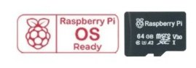
A high-speed microSD card operating inside the onboard Raspberry Pi 5 single-board companion computer. This hardware medium functions as the primary airborne data logger, securely caching raw sent telemetry, navigation strings, and multi-spectral AI alerts locally to provide an uncorrupted baseline for post-flight packet auditing.
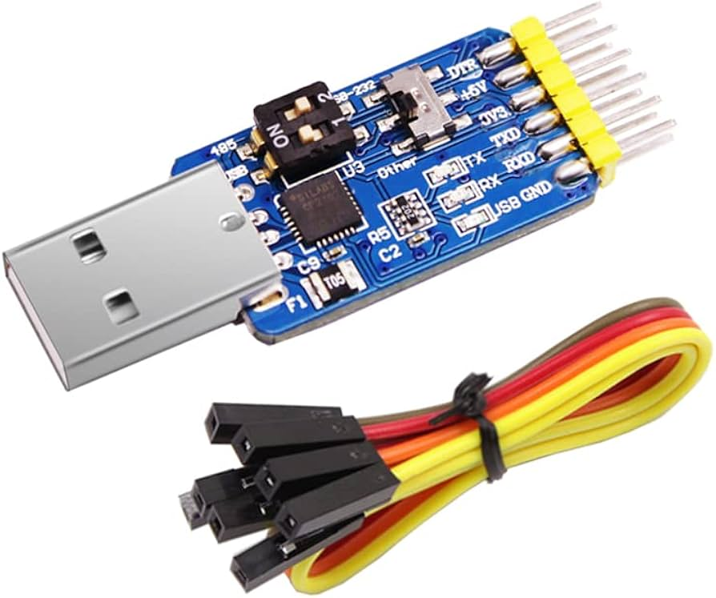
USB-to-TTL Serial Adapter Interface
A dedicated hardware bridge chip (utilizing a CP2102 serial architecture) connecting the ground-side LoRa transceiver directly to the GCS laptop's USB interface. By initializing a virtual COM port, this tool isolates the acquisition of telemetry data on an independent, non-blocking asynchronous background thread, allowing signal strength mapping to occur without interrupting the high-bandwidth 5GHz video feed.
  - Mathematical and Analytical Frameworks
To mathematically quantify the network's behavior and link budget survivability under environmental stressors, two analytical instruments are utilized:
Packet Delivery Ratio (PDR) Formula
A mathematical cross-reference routing script used during the post-flight recovery phase. By evaluating the exact delta between unique airborne sent packets (microSD logs) and unique ground station received packets (SQLite database), the system derives the overall structural reliability of the network link using the following expression:
$$PLR =(\frac{TOTAL PACKETS SENT - TOTAL PACKETS RECEIVED}{TOTAL PACKETS SENT})100$$
Log-Distance Path Loss Model
A predictive radio frequency propagation framework utilized to simulate signal attenuation (d) and antenna performance limits across dynamic field environments. It computes received signal parameters by factoring in the path loss exponent (n) and shadow variations (Xσ ) generated by physical wreckage structures, mapped as follows:
$RSSI =A - 10nlog10(d)+X$σ

Sampling Techniques Field Testing and Operational Environment
  - Testing Location and Topography
Physical flight tests will be conducted in a controlled, open-field environment to ensure an unobstructed Line-of-Sight (LOS) and maintain adequate Fresnel Zone clearance. Intrusion into 60% of the first Fresnel zone by physical obstacles causes severe signal diffraction and attenuation. An open field minimizes multipath fading from urban concrete structures, which can cause phase mismatches and signal cancellation. Additionally, this isolated location lowers the ambient RF noise floor by mitigating external electromagnetic interference (EMI) from commercial Wi-Fi and cellular networks, ensuring clean 5GHz and 915MHz data logs.
  - Spatial Flight Parameters (Distance and Altitude)
To systematically measure signal degradation, Packet Loss Ratio, and End-to-End Latency, the UAV will execute pre-programmed, autonomous waypoint flights. The testing grid is defined by two primary spatial parameters to account for physical signal propagation limits:
- Radial Distances (10m, 50m, 100m, 150m, 200m)
The UAV will hold position at these horizontal increments to measure the effects of Free Space Path Loss (FSPL). Because FSPL increases logarithmically with distance and frequency, the high-frequency 5GHz video stream is expected to degrade much faster than the 915MHz telemetry link. Testing at these specific intervals allows the researchers to pinpoint the exact distance at which bandwidth choking occurs.
- Operational Altitudes (10m, 30m, 50m)
At each horizontal distance, the UAV will be tested at varying vertical altitudes. Altering the altitude changes the relative elevation angle between the transmitting and receiving antennas. This is critical for stress-testing the vertical radiation patterns of the antennas—specifically ensuring the UAV does not inadvertently position the GCS inside the vertical "null zones" (areas of zero gain) of the linearly polarized whip antenna, which would cause an artificial drop in the Received Signal Strength Indicator (RSSI).
  - Meteorological Constraints
RF transmissions are highly susceptible to environmental attenuation and physical disruption. Therefore, to ensure data validity, all flight iterations will be strictly executed under favorable meteorological conditions:
- Clear Skies
Testing will be suspended during rain, dense fog, or high humidity. High-frequency microwaves, particularly the 5GHz band, are vulnerable to "rain fade." This occurs when water droplets absorb and scatter the RF energy (Mie scattering), which would introduce an uncontrolled variable into the RSSI degradation data.
- Minimal Wind Velocity
Flights will only be conducted during low wind conditions (e.g., below 15 km/h). To maintain steady GPS coordinates in high winds, a UAV must aggressively pitch and roll. This extreme banking physically alters the orientation of the onboard antennas. If the transmitting antenna tilts too far out of alignment with the GCS receiving antenna, it causes cross-polarization mismatch, which can result in a massive, instantaneous signal loss (up to 20 dB or more) that does not accurately reflect the transceiver's true hardware capability.

Experimental Deployment and Flight Test Procedures
To systematically evaluate the AERIS dual-link architecture under simulated disaster conditions, a strict operational protocol will be enforced during the field testing phase. This comprehensive procedure will govern the step-by-step execution of the experiment, transitioning from environmental site assessments and RF handshakes to active waypoint navigation and network stress testing.
Stage A: Pre-Flight Site Assessment and Hardware Initialization
Prior to initiating the electronic systems, the researchers will conduct a physical and environmental assessment of the testing perimeter. The operational environment will be visually inspected to ensure the presence of physical obstructions (e.g., concrete structures or dense foliage) necessary to simulate a high-path-loss disaster zone.
- Mechanical Verification: The dual-sensor vision subsystem (RGB and FLIR cameras) will be mechanically verified to ensure the 45-degree oblique mounting angle remains rigidly locked to prevent sensor misalignment during flight resonance.
- Power Initialization: The UAV flight battery will be engaged. The system will rely on the integrated Universal Battery Elimination Circuit (UBEC) to step down the voltage, providing a stable 5V rail. The researchers will verify the LED status indicators on the Raspberry Pi 5 and the Hailo-8L NPU to confirm successful hardware boot and OS mounting.
Stage B: Telecommunications Handshake and Link Verification
Once the onboard microelectronics are initialized, the researchers will initiate the critical telecommunications handshake to establish the heterogeneous dual-link network before the UAV leaves the ground.
- The Sub-GHz LoRa Handshake: The GCS operator will execute the customized PyMAVLink Python script on the field laptop, commanding it to poll the designated COM port of the CP2102 USB-to-UART bridge. The ground-based Ebyte LoRa receiver will listen for the initial MAVLink "heartbeat" packet from the UAV. Upon successful reception, a bi-directional telemetry link will be established. The operator will verify that the initial Received Signal Strength Indicator (RSSI) is stable before proceeding.
- The 5GHz Wi-Fi Handshake: Concurrently, the GCS laptop’s network interface card will scan for the localized 5GHz SSID generated by the UAV's Alfa AWUS036ACM module. The operator will authenticate the connection to this air-gapped Access Point, opening the high-bandwidth UDP pipeline.
- GPS and Video Verification: The operator will monitor the GCS GUI to confirm a 3D GPS lock (verifying sufficient satellite acquisition) and confirm that the H.264-compressed RGB video stream is rendering on the primary display with an initial latency below 50ms.
Stage C: Active Flight, Waypoint Navigation, and Network Stressing
With the handshakes completed and the GCS actively monitoring the UAV, the flight test will proceed to the active data collection phase.
- Deployment: The UAV will be manually piloted to an operational altitude of 20 to 30 meters to establish a baseline slant range.
- Radial Distance Testing: The UAV will be navigated outward from the GCS through predefined radial waypoints (10m, 50m, 100m, 150m, and the maximum 200m edge).
- The Network Stress Test: At each waypoint, the researchers will intentionally stress the network architecture. The Raspberry Pi 5 will be commanded to maximize the bit rate of the RGB visual stream. This action will artificially saturate the 5GHz OFDM channel, simulating the heavy network congestion expected in a real-world disaster scenario and forcing the Wi-Fi link to its absolute bandwidth limit.
Stage D: Edge AI Target Acquisition and Data Logging
While the 5GHz link is subjected to extreme bandwidth stress, the Edge AI subsystem will be tested for target acquisition and telemetry routing.
- Target Identification: Human subjects will be positioned within the testing perimeter, adopting various postures (e.g., standing, prone) to simulate disaster victims. As the UAV flies overhead, the Hailo-8L NPU will simultaneously analyze the thermal matrices and visual frames.
- Alert Generation: Upon achieving a mathematical confidence score that exceeds the YOLOv8 threshold, the NPU will generate the localized survivor alert. This microscopic binary string (containing the GPS coordinates and timestamp) will be injected into a MAVLink packet.
- Automated GCS Logging: The packet will be transmitted via the 915MHz LoRa link. Upon arrival at the GCS, the Python script will automatically log the data into a localized CSV file. The system will record the precise transmission latency and the Packet Loss Ratio (PLR) for that specific radial distance. Simultaneously, the GUI will trigger a visual priority interrupt, actively plotting the survivor's coordinates on the GCS topographical map.
Stage E: Recovery and Post-Flight Data Extraction
Following the successful plotting of targets at the maximum 200m perimeter, the UAV will be recalled to the launch point.
- Safe Shutdown: Upon landing, the GCS operator will manually terminate the PyMAVLink polling scripts and sever the Wi-Fi connection to properly close all software ports. The UAV battery will then be disconnected, allowing the microelectronics to power down safely without corrupting the SD card.
- Data Archival: The raw CSV files containing the PLR, latency metrics, RSSI values, and AI confidence scores will be exported from the GCS laptop and secured for subsequent statistical analysis and data visualization in Chapter 4.

Statistical Treatment and Data Analysis
To interpret the quantitative data gathered during empirical flight testing, the researchers will utilize a combination of descriptive and inferential statistical tools. All data points, including latency, packet delivery metrics, and signal strength, will be exported into localized CSV files for systematic analysis.
End-to-End Transmission Latency
Transmission latency is defined as the time (ms) required for data packets to traverse the link between the UAV and the Ground Control Station (GCS).
- Descriptive Statistics: The sample mean and standard deviation will be calculated to establish the "centroid" of the latency data and to track latency jitters. This measure of variability is vital to ensure that visual feeds remain below the 50ms operational threshold required for real-time edge-based processing
- Two-Way Analysis of Variance (ANOVA): A Two-Way ANOVA will be conducted to examine the simultaneous effects of the two independent variables: radial distance and operational altitude. This inferential test will determine if a statistically significant interaction effect exists between spatial positioning and latency. The ANOVA table will decompose the total variation into main effects and interaction components, utilizing the F-statistic to evaluate whether the systematic variation caused by the flight parameters exceeds unsystematic error.
Table 3.1: Statistical Matrix for End-to-End Transmission Latency (ms) Performance
End-to-End Transmission Latency (ms)
 | Line of Sight Radial Distances
Altitudes | 10m | 50m | 100m | 150m | 200m
10m
30m
50m

Packet Delivery and Link Reliability
Reliability is evaluated through the Packet Loss Ratio (%) and Packet Delivery Ratio (PDR) across the defined testing matrix.
- Descriptive Statistics: Frequency distributions and percentage distributions will be used to visualize dropped packets at each waypoint. These metrics will verify if the 915/923 MHz LoRa telemetry link successfully maintains its reported 97.5% PDR benchmark under infrastructure-denied conditions.
- Chi-Square Test of Independence: This tool will be used to assess whether packet loss occurs independently of the UAV’s spatial coordinates or if environmental configurations—such as antenna tilting leading to cross-polarization mismatch—significantly degrade the link.
Table 3.2: Statistical Matrix for Packet Loss Ratio (%) Link Reliability
Packet Loss Ratio (%)
 | Line of Sight Radial Distances
Altitudes | 10m | 50m | 100m | 150m | 200m
10m
30m
50m

Received Signal Strength Indicator (RSSI)
RSSI, measured in decibels relative to a milliwatt (dBm), provides a quantitative measure of signal degradation over distance.
- Logarithmic Regression Analysis: Because radio frequency power attenuates logarithmically, a logarithmic regression model is required to map empirical RSSI decay. This model follows the Log-Distance Path Loss Model, accounting for environmental attenuation and multipath fading in complex disaster topographies.
- Method of Least Squares (LS) and Comparative Curve-Fitting: The researchers will utilize the Method of Least Squares to estimate model coefficients and plot empirical RSSI curves. These field-tested results will be statistically compared against theoretical baselines derived from the Friis Transmission Equation,. This comparative analysis determines the adequacy of the fitted model and identifies the presence of "null zones" or interference skewed by the testing environment.
Table 3.3: Statistical Matrix for Received Signal Strength Indicator (RSSI) (dBm) Attenuation
Received Signal Strength Indicator (RSSI) (dBm)
 | Line of Sight Radial Distances
Altitudes | 10m | 50m | 100m | 150m | 200m
10m
30m
50m

System Validation Framework
To ensure the physical prototype and the experimental data explicitly answer the foundational objectives of the study, a strict System Validation Framework will be enforced. This framework replaces standard subjective evaluation procedures with a quantitative validation matrix. It structurally maps each Statement of the Problem (SOP) to its respective methodological validation phase and defines the exact threshold of success required to prove the functional integrity of the AERIS architecture. The system will only be considered verified if it meets or exceeds the quantitative criteria outlined below.
- Objective-to-Validation Matrix
Statement of the Problem (SOP) | Methodological Validation Phase | Quantitative Success Criteria & Functional Thresholds
SOP 1: How can a decentralized, air-gapped dual-link communication architecture be designed to ensure reliable, low-latency transmission of telemetry and video data in post-disaster environments? | Phase I: Network Architecture and Mathematical Modeling | - Air-Gapped Verification: Zero reliance on cellular/cloud infrastructure confirmed.  - Link Budget Validation: Mathematical models confirm a minimum Fade Margin of ≥ 10 dB for both frequencies.  - Signal Segregation: Absolute physical decoupling of UDP video (5GHz) and MAVLink telemetry (915/923MHz).
SOP 2: To what extent can the proposed system maintain communication performance in terms of:  - End-to-end transmission latency (ms)  - Packet Loss Ratio (%)  - Received Signal Strength Indicator (RSSI in dBm) across varying distances and altitudes | Phase II: System Simulation and Validation | - Telemetry & Handshake Integrity: SITL logs demonstrate zero serial buffer overflows at the 921,600 baud rate while maintaining a persistent 1Hz MAVLink heartbeat exchange.  - Network Reliability Projection: MATLAB/Simulink numerical modeling confirms the architecture maintains the target 97.5% Packet Delivery Ratio (PDR) across all simulated radial distances.  - Video Pipeline Stability: Simulated GStreamer routing successfully compresses the raw visual feed into a stable 5–6 Mbps UDP pipeline without inducing cumulative latency.  - Mission Authorization: The automated pre-flight audit successfully parses GLOBAL_POSITION_INT packets and validates GPS/battery synchronization before permitting autonomous GUIDED mode.
SOP 3: To develop a functional hardware prototype incorporating a Raspberry Pi 5 companion computer, LoRa UART transceivers, and optimized antenna configurations, compliant with Size, Weight, and Power (SWaP) constraints for field deployment.  - Detection accuracy (%)  - Precision and recall  - Detection latency (seconds)  - False positive rate (%) | Phase III: Hardware Integration and Embedded System Prototyping | - Power Stability: UBEC maintains a continuous 5V/5A rail without brownouts during maximum RF transmission and NPU load.  - Interface Functionality: I2C, SPI, MIPI CSI-2, and UART buses establish localized handshakes without bottlenecking the data transmission pipeline.  - Payload Capacity: Total structural weight remains below the UAV’s maximum lift limit to ensure the drone can reach the required operational altitude for Line-of-Sight (LoS) RF testing.
SOP 4: What is the power consumption and operational endurance of the integrated system, considering all onboard components under real operating conditions? | Phase IV: Experimental Deployment and Field Testing | - Video Latency: The 5GHz surveillance downlink maintains an end-to-end streaming latency of ≤ 105 ms to prevent teleoperator disorientation during manual navigation.  - Telemetry Latency: The 915MHz LoRa link maintains an end-to-end transmission latency of ≤ 131 ms, securely accounting for the physical Time-on-Air constraints of Chirp Spread Spectrum modulation.  - Telemetry Reliability: The decentralized 915MHz LoRa MAVLink routing maintains a strict Packet Loss Ratio (PLR) of ≤ 2.5% at the maximum 200m radial edge, guaranteeing the delivery of critical AI survivor coordinates.
SOP 5: How effective is the system when deployed under simulated disaster environments, including:  - Non-Line-of-Sight (NLOS) conditions  - Obstructed environments (debris, vegetation)  Environmental stress factors |  | - Signal Penetration: The Received Signal Strength Indicator (RSSI) for both frequency bands maintains a continuous Fade Margin of ≥ 10 dB above their absolute receiver sensitivity floors across all tested altitudes and distances.

- Framework Transition to Data Analysis
This validation matrix will serve as the primary benchmark for the subsequent data analysis. During the post-flight extraction phase, the raw CSV logs (containing latency metrics, PLR, and RSSI degradation curves) will be directly cross-referenced against these established functional thresholds. Any dataset that fails to meet these strict quantitative criteria will be mathematically analyzed to determine the point of architectural failure, thereby transitioning the methodology directly into the Results and Discussion phase of the study.
  - Communication Performance
The system must meet defined latency and reliability thresholds for both communication links to ensure real-time and dependable data transmission during operations. End-to-end latency is evaluated as the total delay from data acquisition to reception, expressed as:
$$t_{\text{total}}=t_{\text{proc}}+t_{\text{queue}}+t_{\text{tx}}+t_{\text{prop}}$$
where $t_{\text{proc}}$is the processing delay, $t_{\text{queue}}$is the buffering delay, $t_{\text{tx}}$is the transmission delay, and $t_{\text{prop}}$is the propagation delay. For real-time performance, this value must remain below the predefined latency threshold ($t_{\text{total}}≤t_{\text{max}}$).
Reliability is quantified using the Packet Loss Ratio (PLR) and Packet Delivery Ratio (PDR):
$$\text{PLR}=\frac{N_{\text{lost}}}{N_{\text{sent}}}\text{PDR}=\frac{N_{\text{received}}}{N_{\text{sent}}}$$
where $N_{\text{sent}}$is the total number of transmitted packets, $N_{\text{lost}}$is the number of lost packets, and $N_{\text{received}}$is the number of successfully received packets. A reliable system is expected to maintain a low PLR and a high PDR (close to 1).
Additionally, signal quality is monitored using the Signal-to-Noise Ratio (SNR):
$$\text{SNR}=\frac{P_{\text{signal}}}{P_{\text{noise}}}$$
which directly affects communication stability and error rates. Maintaining sufficient SNR ensures robust transmission even under interference or environmental degradation.
Through these metrics, the system ensures that both communication links operate within acceptable limits, achieving low latency, high reliability, and consistent data delivery required for mission-critical applications.

  - Detection Performance
Detection accuracy and reliability must meet predefined performance thresholds to ensure the system’s effectiveness and practicality in real-world search and rescue operations. The accuracy of the detection system is evaluated using:
$$\text{Accuracy}=\frac{TP+TN}{TP+TN+FP+FN}$$
where $TP$, $TN$, $FP$, and $FN$represent true positives, true negatives, false positives, and false negatives, respectively. This metric reflects the overall correctness of the detection model under various environmental conditions.
To further assess detection reliability, precision and recall are used:
$$\text{Precision}=\frac{TP}{TP+FP}\text{Recall}=\frac{TP}{TP+FN}$$
Precision measures the proportion of correct detections among all predicted detections, while recall evaluates the system’s ability to identify all actual targets. These metrics are combined into the F1-score for balanced evaluation:
$$F1=2⋅\frac{\text{Precision}⋅\text{Recall}}{\text{Precision}+\text{Recall}}$$
In addition, system robustness is assessed through the False Positive Rate (FPR):
$$\text{FPR}=\frac{FP}{FP+TN}$$
which quantifies the likelihood of incorrect detections in non-target scenarios.
To ensure real-time operational reliability, detection latency must also satisfy system constraints:
$$t_{\text{detect}}≤t_{\text{max}}$$
where $t_{\text{detect}}$is the time required to detect and report a target, and $t_{\text{max}}$is the maximum allowable delay for timely response.
By meeting these quantitative thresholds, the system ensures both high detection accuracy and dependable performance, making it suitable for practical deployment in dynamic and high-risk disaster environments.
  - Power Performance
The system must achieve stable operation and sufficient runtime to meet mission requirements, ensuring continuous functionality throughout the duration of search and rescue operations. System stability is primarily governed by consistent power delivery and controlled load conditions, while runtime is determined by the relationship between battery capacity and total power consumption.
The total system power demand is expressed as:
$$P_{\text{total}}=V×I_{\text{total}}$$
where $P_{\text{total}}$is the total power (W), $V$is the supply voltage (V), and $I_{\text{total}}$is the total current draw (A). Stable operation is ensured when the power supply is capable of meeting or exceeding this demand without significant voltage fluctuations:
$$P_{\text{supply}}≥P_{\text{total}}$$
The system runtime or operational endurance is calculated using:
$$t=\frac{C_{\text{battery}}}{I_{\text{total}}}$$
where $t$is the operating time (hours), $C_{\text{battery}}$is the battery capacity (Ah or mAh), and $I_{\text{total}}$is the total current consumption. To account for safe battery usage and prevent over-discharge, the effective runtime is adjusted using the Depth of Discharge (DoD):
$$t_{\text{actual}}=\frac{C_{\text{battery}}×\text{DoD}}{I_{\text{total}}}$$
where DoD typically ranges from 0.7 to 0.8 for LiPo batteries.
Additionally, voltage stability must satisfy:
$$V_{\text{out}}≈V_{\text{required}}$$
to ensure proper operation of all components without brownouts or system resets.
By meeting these electrical and energy constraints, the system guarantees stable performance, uninterrupted operation, and sufficient mission endurance, making it suitable for deployment in time-critical disaster response scenarios.

